ANIMALS IN THE LABORATORY - ALLERGENS
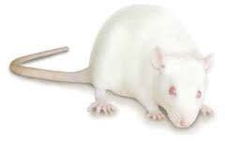

Animals Release Airborne Allergens
Airborne Allergens Can Cause Allergy Symptoms

MILD ANIMAL ALLERGY SYMPTOMS
- Itchy or Watery Eyes
- “Runny” Nose
- Skin Rash or Itchiness
- Nasal Congestion
- Cough

REDUCE YOUR EXPOSURE: USE PERSONAL PROTECTIVE EQUIPMENT
- N-95 Mask*
- Eye protection
- Gloves
- Protective Clothing

* Use of an N95 mask requires fit testing. Call or email Office of Environmental Health & Safety (OEHS) to schedule fit testing at (313) 577-1200 or oehs@wayne.edu.
For more information on animal allergen exposure reduction, visit Animal Contact on OEHS website.

