Laboratory Health and Safety Facts
Using a Chemical Fume Hood

What is the purpose of the laboratory chemical fume hood?
- The fume hood is the most important local exhaust device used in laboratories. When used properly, it will protect the user from exposure to potentially harmful chemicals and other hazardous air contaminants. It is important to remember that the hood is part of the building’s complete ventilation system, and its performance is influenced by other parts of the system.
- Successful hood performance depends on the velocity of air moving through the hood. Airflow is affected by cross drafts, opening height, thermal loading and objects placed in the hood.
- The hood sash is meant to protect the user from exposure to harmful vapors, and to minimize the effects of explosions, fires, spills or splashes that may occur in the hood.

What is the proper function of the hood?
- To adequately protect the fume hood user, the linear face velocity of air into the hood should be between 70 and 130 feet per minute (fpm).
- Arrows on the side of the hood or sash stoppers indicate where the sash should be positioned to achieve the ideal airflow rate. This sash height is set between 12 and 18 inches from the bottom of the opening to protect the user and allow adequate room to work. When working in the hood, the sash must be at the height indicated by the arrows or stoppers to ensure safe operation. Lowering or raising the sash height will negatively impact the airflow.
- Keep in mind that faster velocities, especially above 250 fpm, create hazardous conditions by interfering with operations such as transferring dry chemicals and flame control on burners.
- A fume hood that is not performing properly is often worse than no hood at all because the user is likely to have a false sense of security about its ability to provide protection.
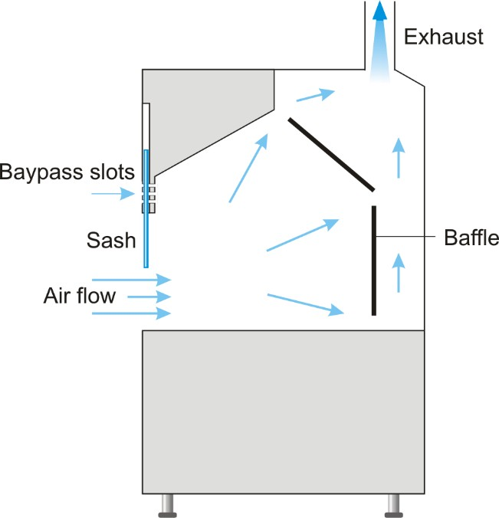

What are the procedures for safe use of a fume hood?
- Know the health hazards of the materials you are working with and become familiar with the signs and symptoms of overexposure.
- For optimum safety, use all hazardous chemicals in the hood. Always perform procedures with highly toxic materials in the hood, especially those with a permissible exposure limit (PEL) of 50 ppm or less. See the chemical specific SDS for this information.
- Perform work at least 6 inches into the hood to ensure that air is being adequately exhausted away from you and protecting you from exposure to hazardous vapors.
- Keep only equipment and chemicals necessary for your experiment in the hood. When possible, raise equipment at least 2 inches off of the work surface to allow for better airflow.
- Eliminate clutter in the hood. Fume hoods are not meant for storage of chemicals, lab equipment, or waste.
- Keep combustibles, such as paper towels, out of the hood. Besides being a fire hazard, paper items may also become drawn into the hood exhaust system, blocking or restricting airflow.
- Do not block the rear hood exhaust slots with equipment or materials. Keep items at least three inches away from back baffles.
- Minimize traffic near the hood to minimize airflow disruption.
- Do not position fans or air conditioners in the room in a manner that will direct air flow across the face of the hood and interfere with containment.
- Never stick your head into the hood or leave the sash fully open during experiments involving hazardous materials.
- Chemical fume hoods should never be used as a means of evaporating old or unwanted chemicals. Submit all chemical waste disposal requests to the Office of Environmental Health and Safety (OEHS).
- Completely close the hood sash or panels:
  - At the end of the day
  - When leaving experiments or chemicals unattended.
  - When the hood is not in use.

What are the criteria for evaluating fume hood performance?
- Chemical fume hood performance is evaluated and certified annually by OEHS. OEHS submits work orders to Facilities Planning & Management (FP&M) for hoods that do not pass certification. FP&M is responsible for adjusting and repairing fume hoods.
- The sash must be able to be opened, closed, and adjusted to the appropriate working height.
- Air velocity measurements are taken at five points across the opening (or face) of the hood and averaged. The average face velocity must be between 70-130 fpm to pass certification. The ideal average face velocity should be ~100 fpm at a sash height of 15 inches.
- If a fume hood has an airflow monitor, it must be functioning and indicate a similar airflow as the average of measurements taken at the face of the hood.
- For evaluation of a chemical fume hood or for more information, contact the Office of Environmental Health and Safety at (313) 577-1200.

