**Does your lab ship hazardous materials or any materials on dry ice?**

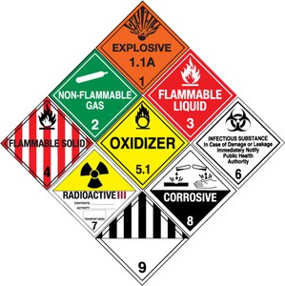

* Hazardous materials must be shipped by an Office of Environmental Health & Safety (OEHS) staff member or other trained personnel.

**Under DOT Dangerous Goods regulations, penalties for violations are severe.**

* **DRY ICE is a Class 9 – Miscellaneous Dangerous Good**:

ALL materials on dry ice are regulated and must be shipped as dangerous goods.

* **LITHIUM BATTERIES are Class 9 – Miscellaneous Dangerous Goods**:

These batteries are regulated and require special packaging and labeling.

* Some chemical and biological compounds are non-regulated and may be shipped without Dangerous Goods training.
* Contact OEHS for shipment of hazardous materials, or for assistance in determining if your shipment is hazardous.

[Office of Environmental Health & Safety (OEHS)](https://research.wayne.edu/oehs) (<https://research.wayne.edu/oehs>)

(313) 577-1200

oehs@wayne.edu