Wayne State: Registration Guide

Registration Process for Internal Users

- Navigate to the following URL: https://waynestate.ilab.agilent.com/account/login
- Bookmark this URL for future use.
- Once on the iLab login page, select ‘Wayne.’
- At this point you will be prompted to provide your Wayne State and password.

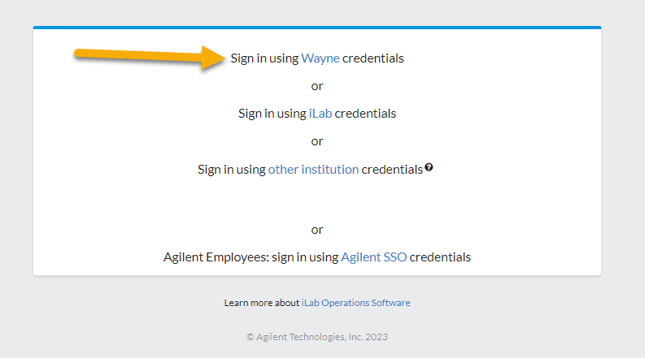

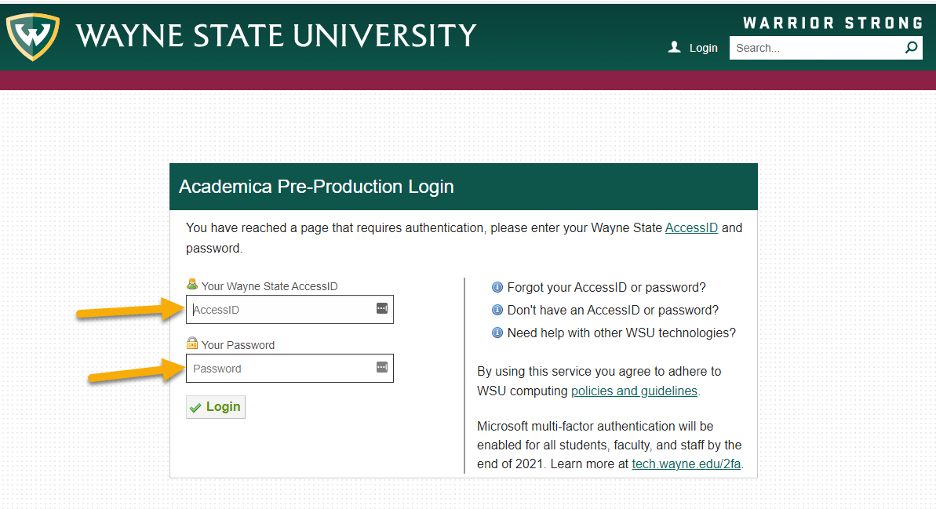

  - If this is your first time logging in, once you authenticate you will be directed to a registration page.
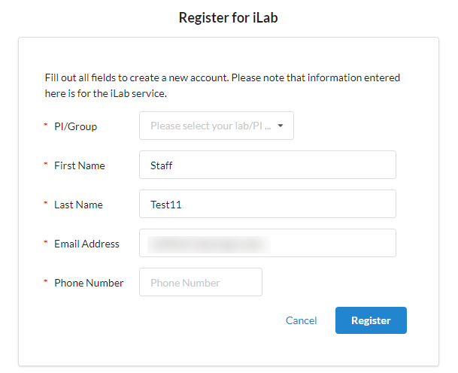
- First select the appropriate PI/Group from the first drop down.

- Your first name, last name, and email address will be pre-filled. Complete any remaining required fields.
- Click ‘Register.’ The next page you see will be the ‘Greeting Page’
- The PI you selected has been sent an email informing them that they need to approve your account.

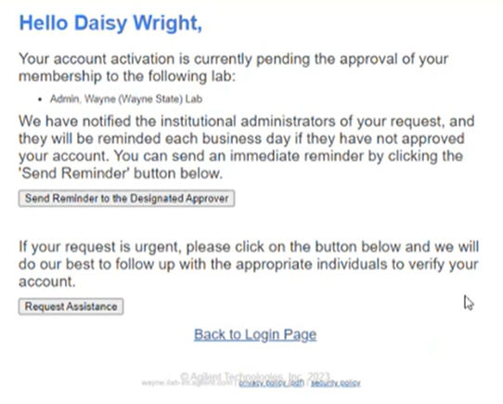

- The PI is reminded each business day but you have the opportunity to send an additional reminder.
- You will also receive a Welcome email with brief getting started instructions.
- Once your account has been approved you will receive an email notifying you.
- Now you can login following steps 1-4 to utilize the core facilities within iLab
- Once logged in you will be on the iLab homepage dashboard. Make sure to set your time zone!

