REFRIGERATION / FREEZING OF FLAMMABLE LIQUIDS
- Flammable liquids must never be stored in standard domestic refrigerators, freezers, or cold rooms
  - Vapors from the stored chemicals can accumulate over time and come in contact with an electrical spark, thus creating a powerful explosion
    - Sparks can occur with normal operations of these appliances such as when the thermostat, defrost timer, internal lighting unit, or the motor turns on and off
  - Even a small quantity of flammable liquid stored in a non-approved refrigerator or freezer can cause a large explosion
  - Explosions, injuries and costly laboratory fires have resulted from storing flammable liquids in domestic refrigerators or freezers
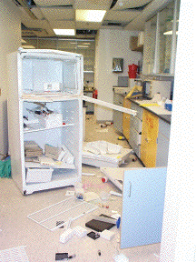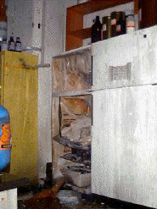
University of Vermont: Flammable liquids stored in a refrigerator resulted in an explosion.
University of Virginia:
A thermostat spark ignited flammable vapors.

- Flammable material refrigerators and explosion-proof refrigerators are designed to prevent ignition of flammable vapors and can be used for storage of flammable liquids
  - A flammable liquid is defined by OSHA 1910.1200 App B Physical Criteria as having a flash point of not more than 93°C (199.4°F).
    - Review the Safety Data Sheet (SDS) for the flash point of liquids
- Flammable-safe refrigerators will be U.L. listed, and bear a label stating “FLAMMABLE STORAGE ‐ KEEP FIRE AWAY”
- Explosion proof refrigerators are constructed so that there are no sparks or static charges generated either inside or outside of the unit
  - These refrigerators are typically used in specialized locations such as solvent dispensing rooms
- Avoid storing flammable liquids with strong oxidizers or acids and provide suitable secondary containment
- Chill flammable liquids safely in an ice bucket prior to use rather than storing them in a standard domestic refrigerator

COMMON LABORATORY SOLVENTS
Do not store these flammable liquids in standard domestic refrigerators
Chemical | Flash Point (⁰F) | Chemical | Flash Point (⁰F)
Acetone | 4 | Isopropanol | 53
Acetonitrile | 42 | Methanol | 54
Benzene | 12.2 | Petroleum Ether | 20
Butanol | 84 | Propyl Alcohol | 74
Cyclohexene | 10 | Pyridine | 68
Dioxane | 54 | Tetrahydrofuran | 6
Ethyl Acetate | 24 | Tetramethylethylenediamine | 50
Ethyl Alcohol | 55 | Toluene | 40
Ethyl Alcohol (20%) | 97 | Triethylamine | 20
Ethyl Ether | -49 | Xylene | 84
Hexane | -7

