Safe Transfer of Flammable Liquids:

Grounding and Bonding
Introduction:
Transfer of flammable liquid from one container to another or splashing and turbulence of the liquid in the container, creates friction between the liquid and the container. This can cause a buildup of a static electricity (charge). If there are no means to drain the static electricity buildup, there is a risk that a sufficiently high electric potential difference (voltage) will develop to generate a spark, which may ignite the flammable vapors in the area causing a fire or explosion.
Grounding and bonding is an effective technique for minimizing this risk. This technique safely drains the static electricity built up during liquid transfer into the ground by creating an electrical pathway between a dispensing container, a receiving container, and an earth ground.
Bonding is the process of connecting two or more conductive objects together by means of a conductor so that they are at the same electrical potential, but not necessarily at the same potential as the earth [NFPA 77 - 3.1.2].
Grounding is the process of bonding 1 or more conductive objects to the ground, so that all objects are at zero (0) electrical potential; also referred to as "earthing" [NFPA 77 - 3.1.10]
Requirements for bonding and grounding of flammable liquids:
Depending on the volume of the dispensing (source) container (Table 1), containers (metal or non-metal) carrying flammable liquids with flash point <100°F (GHS category 1, 2 and 3*) must be grounded and bonded.
* for flammable/combustible liquids with flash point > 100°F: bonding and grounding during transfer is required only if the liquid has been heated above its flashpoint.

Table 1: Requirements for bonding and grounding of flammable liquids based on the size of the dispensing container.
Size of the dispensing (source) container | Examples | Bonding and grounding required? | Location to perform transfer****
Small  volume ≤ 1 gallon (4 L) | 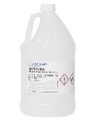 | No | Chemical fume hood  Standard Lab bench
Medium  volume > 1 gallon (4 L) and < 20 gallons (75 L) | 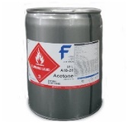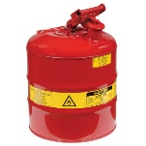 | Yes*** | Chemical fume hood  Standard Lab bench  Flammable liquid storage room
Large**  volume ≥ 20 gallons (75 L) and < 55 gallons (208 L) | 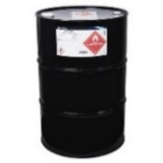 | Yes*** | Flammable liquids storage room  Outdoors
** Metal containers only
*** Contact WSU Fire Marshall for assistance with initial setup
**** Location of transfer should always be in a well-ventilated area and MUST be away from open flames or heat sources (e.g., hot plates, Bunsen burners etc.) and/or electrically charged equipment.

Steps for safe transfer of flammable liquids using grounding and bonding
The pictures below illustrate a bonding and grounding system setup for small volume solvent transfer from a dispensing container to a metal (Figure 1) or non-metal (Figure 2) receiving container. It is recommended that users contact the WSU Fire Marshall (313 577-3110) or OEHS (313 577-1200) for assistance with initial setup.
Figure 1: Grounding and bonding when using a metal receiving container
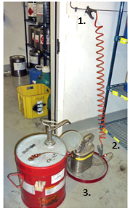 | - Connect the dispensing vessel to the earth ground or a building static grounding system using a grounding cable. Some locations may have permanent grounding cables available.
 | - For metal containers, connect the bonding cable from the dispensing vessel to the receiving vessel directly or via a metallic floorplate.
 | - A metallic floorplate is used to provide a bond for the receiving container. It can also serve as secondary containment during the transfer process.

Figure 2: Grounding and bonding when using a non-metal receiving container
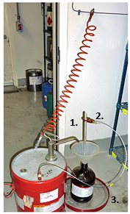 | - If the receiving container is made of non-conductive material (i.e., glass or plastic) or does not have a metal connection, then use a metal grounding rod or wire inserted into the receiving container.  A grounding rod is an easily cleaned, nonreactive metal rod designed to provide a bonding point for non-metallic containers.  Provide sufficient support for the grounding rod so that it does not cause the container tip over.
 | - Connect the bonding cable from the dispensing vessel to the grounding rod directly.
 | - Secondary containment must still be provided during the transfer process.

Once containers are properly connected, transfer the liquid slowly to avoid splashing and turbulence which creates more static electricity. When transfer is complete, disconnect all bonding and grounding cables and remove the grounding rod if applicable.
Further information on grounding and bonding procedures and required equipment [grounding and bonding cables, grounding rods, dispensing pumps and metal floor plates (secondary containers)] can be obtained from different vendors including Grainger, Justrite, and FisherScientific.
Reference: University of California San Diego - Bonding and grounding during flammable liquid dispensing.

