Laboratory Signage Guide for Non-Laboratory Staff 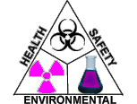

Custodians, building engineers, skilled trade workers, and other non-research personnel frequently perform work in laboratories containing hazardous materials. You have the right to know the nature of the potential hazards present in these labs.

All labs should have the yellow caution sign (seen on the next page) posted next to each entrance to the room. Lab supervisors are responsible for filling in emergency contact information near the bottom of the placard. Below that, contact numbers are listed for the WSU Police and the Office of Environmental Health & Safety (OEHS).

Follow these general recommendations when servicing labs:
- Review hazard signage and consult with lab personnel prior to entering a lab. Enter labs only when necessary, preferably when lab personnel are present.
- Only touch laboratory items after consulting with laboratory personnel to understand the hazards present, how to protect yourself, and/or have verified it is safe to handle. Some items may need to be decontaminated prior to handling or repairing.
- Do not work alone if you are doing anything that requires extensive time and/or direct work on equipment or systems. A member of the lab staff should be present.
- If you are working on a chemical fume hood, the lab staff is responsible for removing all items and decontaminating all surfaces before you begin your work.
- Wear gloves when pulling trash, fixing equipment, or handling anything you suspect could be contaminated.
- Wear safety glasses or goggles when there is a risk of a hazardous materials exposure to the eyes. This includes chemical and biological materials.
- Wash hands before exiting the lab, even if you have been wearing gloves.
- Notify the lab supervisor and your supervisor when inappropriate waste disposal is found (i.e., sharps in regular trash)
- If you suspect there has been a spill or release of hazardous material, alert others, remove yourself from the area, and get to a safe location to report the situation. The lab staff should determine whether to clean-up spill or request help from the OEHS.
- If an exposure occurs, wash the affected area with soap and water. Exposures to the eyes should be immediately flushed using the nearest eyewash station for a minimum of 15 minutes. Notify your supervisor immediately and seek medical attention if necessary.
- Use common sense! Ask questions and notify supervisors with your concerns. Remember, you have a Right-To-Know!

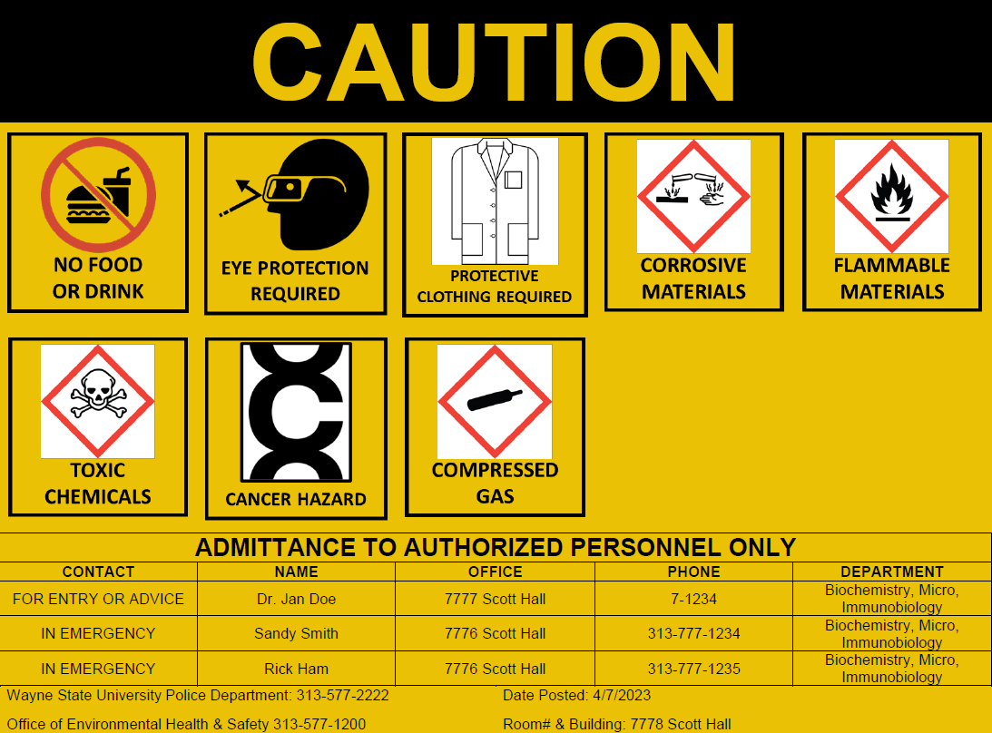

WSU Laboratory Caution Placard Example: WSU OEHS has developed standard laboratory signage which should be posted next to the door of each laboratory entrance. Review the Caution placard to understand the hazards present in the lab. An example is shown above.

Hazard Warning Signs for Laboratories

These are some of the most common labels you will see on lab doors. For information about a hazard that is not shown here, contact OEH&S at 577-1200.

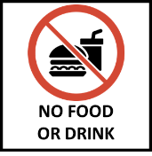 | 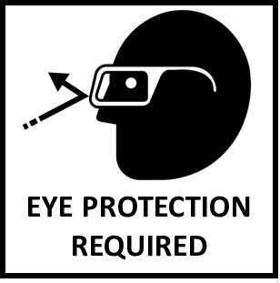 | 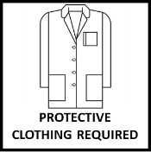 | 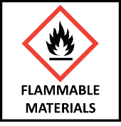 | 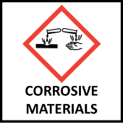 | 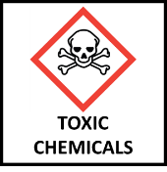
STANDARD POSTING FOR ALL LABS  Absolutely NO eating or drinking is allowed in laboratories at ANY time.  Even closed containers of beverages such as soda, juice, water, etc. are not allowed in labs.  Eating and drinking in laboratories is a violation of federal law. | STANDARD POSTING FOR ALL LABS  Eye protection is required of all personnel working in the laboratory to protect eyes from exposure to chemical or physical hazards, or potentially-infectious materials. Safety glasses or goggles must be worn in areas where experiments are being performed in the area, and whenever you are mixing cleaning products | STANDARD POSTING FOR ALL LABS  Lab personnel are required to wear protective clothing such as lab coats, gloves, etc. while performing experiments. It is for their immediate protection while working.  Protective clothing is NOT required for anyone not in immediate danger of spills, splatters, etc. | Flammable liquids and solids are used in many labs on campus. When not in use, these materials should be kept in flammable storage cabinets.  It is usually safe to enter these rooms, but if your work may create a spark or static electricity, consult with lab personnel BEFORE beginning work to make sure it is safe to proceed. | Corrosive materials have an extremely high or extremely low pH and can cause severe damage to skin and eyes.  This label will be on labs and on storage cabinets inside labs where the chemicals are kept.  Examples of corrosives are sulfuric acid, also called battery acid and sodium hydroxide, also called lye. | Some chemicals can quickly cause illness in humans or are dangerous in very small amounts. The biggest risk is to the researcher working directly with the material.  This sign will be posted outside the lab and inside the lab on storage cabinets where these chemicals are kept.
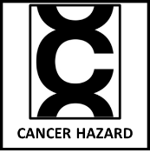 | 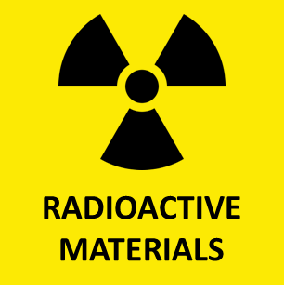 | 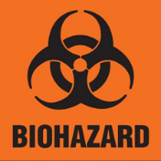 | 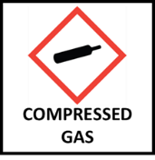 | 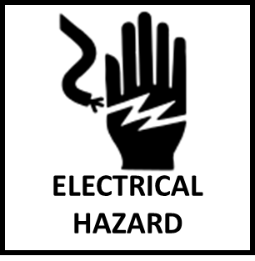 | 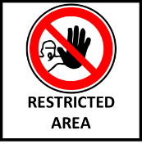
OSHA/MIOSHA classifies certain chemicals as cancer-causing. Areas where these chemicals are used or stored will have this warning label.  The risk of exposure to these chemicals is low for anyone not actually working with them. In most cases, basic protective clothing, such as gloves, is all that is necessary to protect NON-LAB staff. | Radioactive materials or waste are used or stored in this lab.  Work areas are cleaned and tested for radioactivity regularly by lab personnel for everyone’s safety.  DO NOT collect or handle bags or bins that have the radiation symbol on them. | Biohazard labels are placed at lab doors and on refrigerators, freezers, incubators and regulated waste containers that hold potentially-infectious materials.  Work and storage areas for these materials are to be properly cleaned and maintained by lab personnel to ensure everyone’s safety. | Many labs across campus use compressed gases as part of research. The gases used may be asphyxiants, flammable, oxidizers, corrosive, or toxic. If your work may create a spark or static electricity, consult with lab staff to make sure it is safe to proceed. If you discover a gas leak, notify lab personnel and evacuate the area. | Electrical hazards are present in labs that have exposed or unguarded electric power sources.  These labs may be anywhere on campus but are most common in the physics and engineering buildings.  For your protection DO NOT move or handle loose wires or any electronics components unless qualified to do so. | Some labs contain highly regulated materials, equipment, or documentation that is very dangerous, confidential, or both and only authorized lab personnel are allowed to enter. If you see this label outside of any lab, DO NOT enter the room without permission from the principal investigator. Authorized personnel must be present while you work in the space.

