Research and Teaching Laboratories Safety Sign System Manual

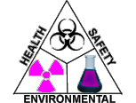

Office of Environmental Health and Safety
5425 Woodward, Suite 300
Detroit, Michigan 48202
313.577.1200
http://www.oehs.wayne.edu

This is a “controlled” document. The Office of Environmental Health and Safety restricts routine distribution. Persons in possession of a printed or saved version of this document may have an uncontrolled copy and should visit the OEHS website for the most up to date version.

Revision Date: 5/1/2023

Table of Contents
Introduction 3
Emergency Procedures Sign 4
Laboratory Caution Sign 5
Hazard Pictograms and Statements 7
Chemical Physical and Health Hazard Pictograms 12
Biosafety Labels and Signs 17
Other Safety Warning Signs 19
Outdated CAUTION Placard Symbols 23
References 25

Introduction

Wayne State University is committed to managing all hazardous materials used and stored at its facilities in a safe and environmentally responsible manner. Wayne State University is also committed to maintaining a safe work environment for its faculty, staff, students, and visitors. In accordance with the commitment to a safe work environment OEHS has developed this laboratory warning signage documents. The manual contains the signage system that is designed to provide emergency responders, laboratory personnel, facilities staff, and visitors with information regarding the presence of potential laboratory hazards, required precautions for entry, and emergency contact information. The signage system also ensures compliance with federal and state regulations, which require signs to identify areas where hazards exist which could harm workers, the public, or result in property damage. These laboratory signs do not list every hazard associated with a lab but focus on the hazards of highest concern within a given space. Laboratory signs do not replace basic laboratory safety training or practice.

All persons in supervisory or management positions are responsible for proper signage in their areas, and for ensuring University guidelines for labeling are followed. Completion of a risk assessment of the hazards present in each room and an annual chemical inventory for each area are recommended to aid in identification of appropriate lab signage. The annual chemical inventory must be submitted to OEHS and can be documented using the Laboratory Chemical Inventory Form.

Teaching laboratories should include information in the course specific laboratory safety training about laboratory signage and the symbols posted for the room(s).

Note: Substances listed under OSHA 29 CFR 1910 Subpart Z - Toxic and Hazardous Substances may have specific warning sign requirements not outlined in this document. Laboratories working with and storing these substances must review the substance specific regulation to ensure appropriate hazard warning compliance.

Emergency Procedures Sign

In case of an emergency, a quick response is needed to minimize negative consequences and to provide immediate medical attention if necessary. Post the Emergency Procedures sign in the lab near a phone or in a highly visible spot such as just inside the lab entrance. Train laboratory personnel on WSU and lab specific emergency procedures. An example Emergency Procedures sign is shown below. For the most up to date version, a printable copy of the sign can be found on the OEHS website at this Emergency Procedures link.

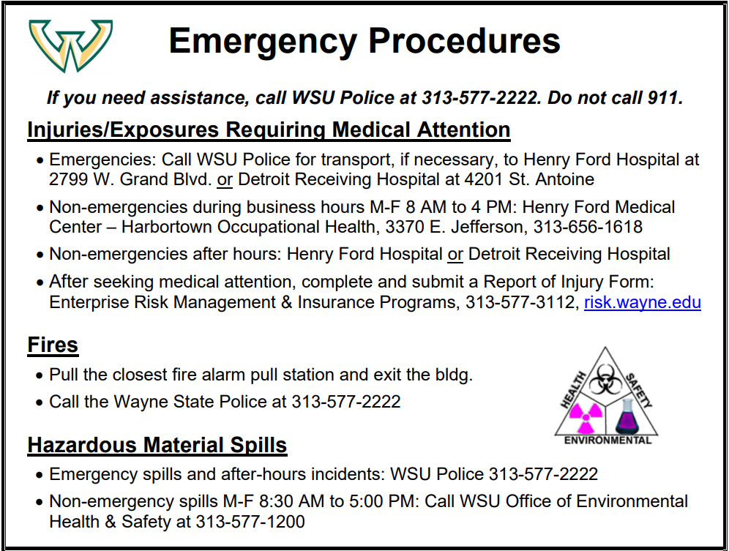
Figure 1: Example of the WSU Emergency Procedures sign.

Laboratory Caution Sign

The Laboratory Caution Sign illustrated in this section (Figure 2) is intended to warn personnel of the hazards that exist in an area. The specific hazards are indicated by symbols and/or hazard warnings affixed to the placard. In addition, signs should include symbols indicating personal protective equipment required for entry. The Laboratory Caution Sign and hazard pictogram stickers can be obtained from OEHS by submitting a request using the following form: Request a Lab Caution Sign and Hazard Labels.

The pages following Figure 2 list the available hazard pictograms and the corresponding definitions of conditions warranting posting of each label. Some hazard pictograms include a threshold level as to when the pictogram is required. If more than one hazard exists in an area, the appropriate labels (up to a total of ten) should all be displayed on one placard. A risk assessment of the laboratory should be conducted to identify the hazards of highest concern and the respective pictograms to be posted. A risk assessment should include referencing safety data sheets (SDS) to identify hazardous materials.

All laboratories, support rooms, and laboratory storage areas containing hazardous materials, hazardous equipment, or other physical hazards must be posted with the Laboratory Caution Sign. Signs will be posted at the entrance(s) to each functionally separate lab. Do not post on the laboratory door, but instead the wall immediately adjacent to the door at approximately eye level. All entrances to laboratories from hallways must be posted with a completed sign. Entrances to laboratory prep rooms that serve multiple labs or require different labels from the main lab will also be posted.

Emergency contacts: These are a required element of the Laboratory Caution Sign and should include a phone number which can be used to contact the individual at any time (day or night). Emergency contacts should include the contact information for:
- The Principal Investigator (PI) or laboratory manager (for teaching labs or shared spaces) and
- At least one current lab member or department representative knowledgeable about the operations being conducted in the laboratory in order to provide assistance to visitors and support personnel who have a need to access the lab.
If an individual posts a WSU phone number, the individual should consider setting up call-forwarding on the office phone to the individual’s home or cell phone number. Information regarding call forwarding can be found at the WSU C&IT web page “How do I forward my incoming calls to a different number?”.

The Caution sign must be updated as information changes and reviewed annually, whichever occurs first. The PI or lab manager in charge of the laboratory must verify the information is updated at least once per year and date the posting.

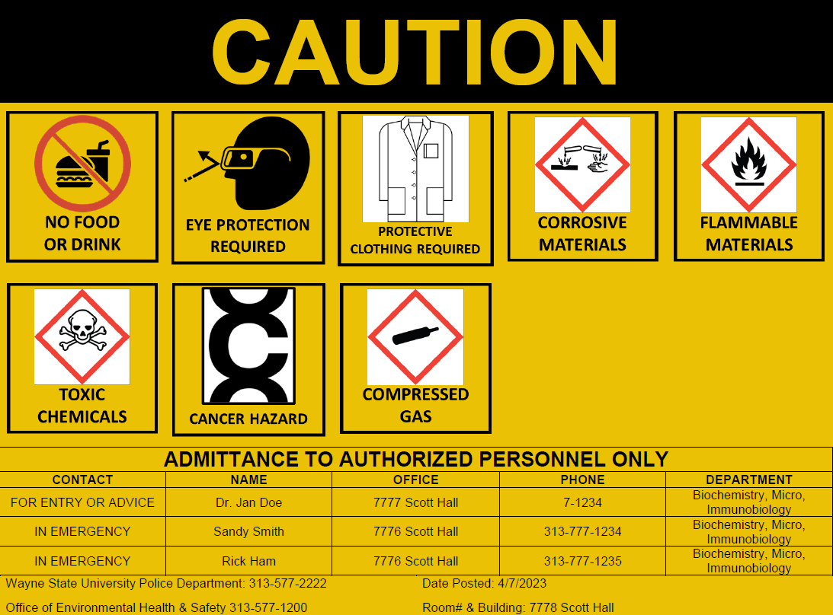
Figure 2: WSU Laboratory Caution Placard Example

Hazard Pictograms and Statements

The NO FOOD OR DRINK label must be posted at access points to all laboratories where chemical substances are used or stored; all laboratories or rooms where radioactive materials are used or stored; and all laboratories or rooms where biohazardous materials are used or stored.

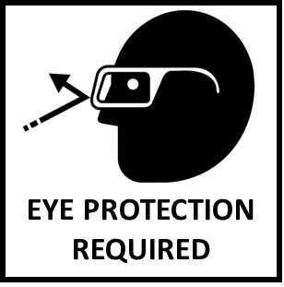
The EYE PROTECTION REQUIRED label must be posted at access points to all laboratories where there is a reasonable probability of exposure to hazardous chemicals, potentially infectious agents, or physical hazards which could result in injury if eye protection is not used.

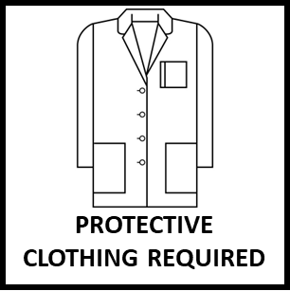
The PROTECTIVE CLOTHING REQUIRED label must be posted at access points to all teaching laboratories where there is a reasonable probability of exposure to hazardous chemicals, biohazardous agents, or potentially infectious materials. This label will also be posted at access points to analytical and research laboratories where the Principal Investigator or laboratory manager has specified protective clothing beyond the standard lab coat.

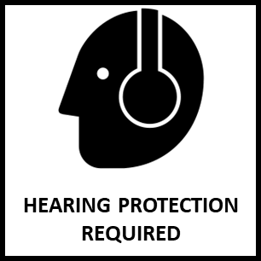
The HEARING PROTECTION REQUIRED label is to be posted at access points to research spaces where noise exposures equal or exceed an 8-hour time-weighted average sound level (TWA) of 85 decibels measured on the A scale (slow response) or, equivalently, a dose of fifty percent (OSHA action level). Locations where impulsive or impact noise that exceeds 140 dB peak sound pressure level may also require this warning label. If researchers suspect noise levels may reach the OSHA action level, contact OEHS to conduct noise monitoring.

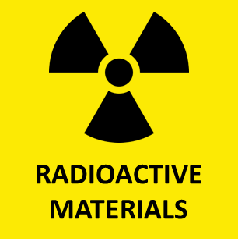
The RADIOACTIVE MATERIALS label must be posted at access points to laboratories where radioactive materials are used or stored, or where radioactive wastes are accumulated.

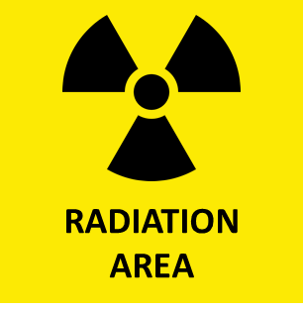
The RADIATION AREA label is posted at the entrance to any area in which radiation levels could result in an individual receiving a dose-equivalent in excess of 0.05 millisievert (5 millirem) in one hour at 30 centimeters from the source of radiation or from any surface that the radiation penetrates.

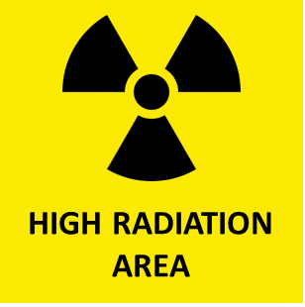
The HIGH RADIATION AREA label is posted outside any area in which radiation levels could result in an individual receiving a dose-equivalent in excess of 1 millisievert (100 millirem) in one hour at 30 centimeters from any source of radiation or from any surface that the radiation penetrates.

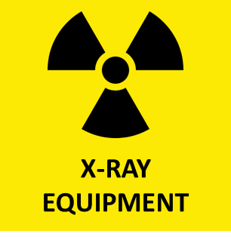
The X-RAY EQUIPMENT label will be posted at access points to laboratories which use an x-ray system, subsystem, or component thereof. Types of x-ray equipment are as follows:
- Mobile x-ray equipment means x-ray equipment mounted on a permanent base with wheels and/or casters for moving while completely assembled;
- Portable x-ray equipment means x-ray equipment designed to be hand-carried; and
- Stationary or fixed x-ray equipment means x-ray equipment which is installed in a fixed location.

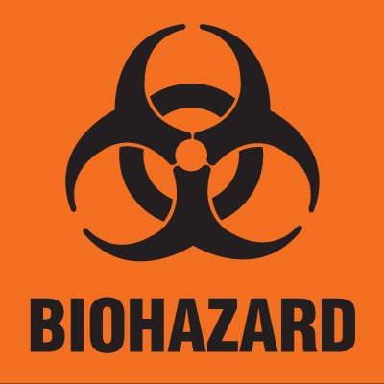
The BIOHAZARD label will be posted at access points to laboratories which use or store risk group 1 or higher agents, human blood, or other potentially infectious agents/materials.

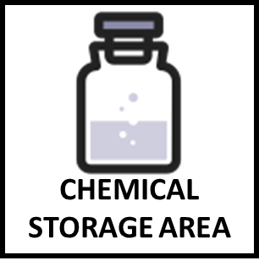
The CHEMICAL STORAGE AREA label will be posted at access points to chemical stockrooms or storage rooms utilized by more than one researcher for chemical storage.

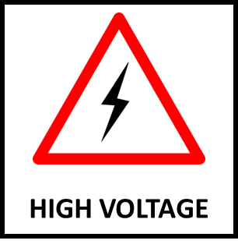
The HIGH VOLTAGE label must be posted at access points to laboratories containing accessible electrical equipment or cables operating at 600 volts or greater. These areas must be accessible to qualified persons only or persons accompanied by a qualified person. A “Qualified person” is defined as one who has received training in and has demonstrated skills and knowledge in the construction and operation of electric equipment and installations and the hazards involved (OSHA 29 CFR 1910.399).

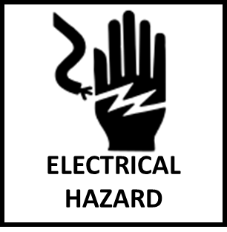
The ELECTRICAL HAZARD label must be posted at access points to laboratories containing accessible equipment with exposed and unguarded electrical components operating at less than 600 volts.

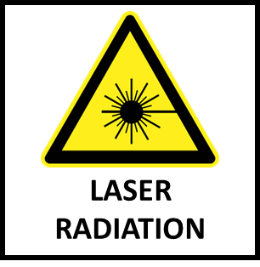
The LASER RADIATION label must be posted at access points to laboratories where Class 2, 3 or 4 lasers are used or stored. The hazard warning must be supplemented by posting a DANGER, WARNING, or CAUTION placard (supplied through the Office of Environmental Health and Safety) when lasers are in operation (see the Other Safety Warning Signs section of this manual for an example). Protective eyewear capable of absorbing the exact wavelength of the produced laser light must be worn by all personnel with potential for beam exposure in these laboratories.

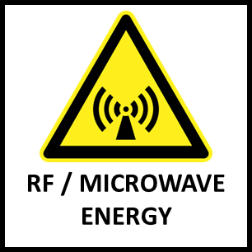
This RF/ MICROWAVE ENERGY label must be posted at access points to laboratories where there is potential for personal exposure to microwave radiation (frequency 300 MHZ to 30 GHz) in excess of 10 mW/cm² as averaged over any possible six-minute period.

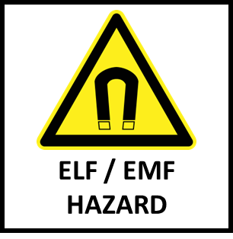
The ELF/EMF HAZARD label must be posted at access points to laboratories containing equipment capable of generating an electrical field of 10 kV/m or more or a magnetic field of 0.5 mT or more. ELF/ EMF - Extreme Low Frequencies/ Electromagnetic Fields radiation.

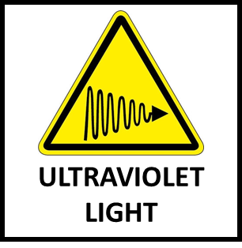
The ULTRAVIOLET LIGHT label must be posted at access points to laboratories using non-laser equipment capable of producing UV wavelengths between 180 and 400 nm at or above the following intensities:
Wavelength (mm) | mJ/cm²
180 | 250
200 | 100
250 | 7
300 | 10
350 | 1.5 x 10⁴
400 | 1.5 x 10⁵
The full curve is located in the annual "Threshold Limit Values" published by the American Conference of Governmental Industrial Hygienists. Additional lab signage may be required.
Examples of when to post this pictogram include when using transilluminators (gel box); hand-held UV lights; UV lights used in insectories; or UV lights used for mutations in plants

NOTE:
- Biological Safety Cabinets with UV lamps will not be evaluated as a UV hazard unless work requires the lamp be activated when the cabinet is in use with the sash raised.
- Crosslinkers are exempt due to engineered safety features providing protection.
- UV lasers will be posted with the laser radiation label.

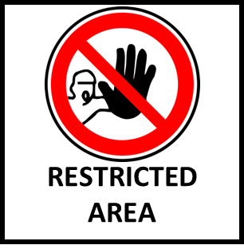
The RESTRICTED AREA label signifies controlled access to the laboratory and is restricted to only authorized laboratory and emergency response personnel unless the laboratory manager grants permission for entry and confirms the space safe for entry. Restricted areas are hereby defined as spaces where:
- ionizing radiation is generated;
- radioactive materials are used or present;
- accessible electrical equipment or cables operating at 600 volts or greater are present; or
- proprietary or confidential materials are used or stored

Chemical Physical and Health Hazard Pictograms
The hazards outlined below are based on the Globally Harmonized System of Classification and Labelling of Chemicals (GHS). The hazard classifications in this system are each broken down into levels of severity (called Categories, Divisions, or Types). Chemicals present in the lab which have been identified as being in the higher severity categories (e.g. Category 1 and Category 2) are typically an indication that a particular hazard pictogram should be included on the Laboratory Caution sign. Information about which classification(s) and category a chemical belongs in can be found in the chemical’s safety data sheet (SDS). A threshold amount may also be listed below to provide guidance as to when a hazard pictogram should be used.

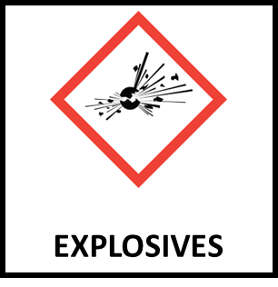
The EXPLOSIVES label must be posted at access points to laboratories or storage areas regularly storing any amount of explosive materials (Unstable Explosives; Divisions 1.1 – 1.3; Desensitized explosives Category 1 and 2) or ≥ 1 kilogram of organic peroxides (Types A-D).

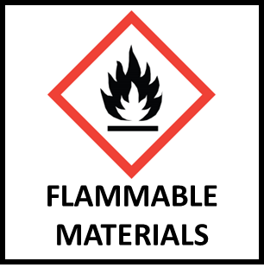
The FLAMMABLE MATERIALS label must be posted at access points to laboratories or storage areas regularly storing any of the following:
- Any quantity of a category 1 or 2 flammable liquid
- 4 liters or more of a category 3 or 4 flammable liquid stored outside of a flammable storage cabinet
- Any quantity of a flammable solid (Category 1)
- Any quantity of a water-reactive, self-heating, or pyrophoric substances (Category 1 or 2)
- Any quantity of self-reactive substances (Type A – D)
- Any quantity of a flammable gas (Category 1)
- Any quantity of extremely flammable aerosol (category 1)

Refer to OSHA 29 CFR 1910.1200 App B - Physical Criteria for more detailed definitions of each substance and severity level listed above.

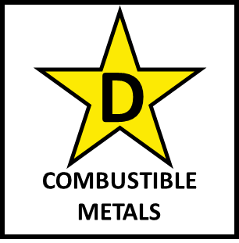
The COMBUSTIBLE METALS label must be posted at access points to laboratories or storage areas regularly storing or creating powders or particulates of metal or metal alloys considered to be flammable solids according to OSHA 29 CFR 1910.1200 App B - Physical Criteria paragraph B.7.2.2 and table B.7.1.
- When powders of metals or metal alloys can be ignited and the reaction spreads over the whole length of the sample in 10 min or less.
Or according to NFPA 484: Standard for Combustible Metals paragraph 3.3.14.
- Combustible metal dust or particulate – A combustible particulate metal, including combustible fibers/flyings, that presents a fire or explosion hazard when suspended in air or the process-specific oxidizing medium over a range of concentrations at standard atmospheric pressure and temperature.
Note: Labs must consult with the WSU Fire Marshal and OEHS to identify appropriate extinguishing agent for these types of metals, prior to purchasing the extinguishing agent.

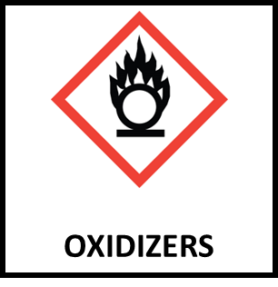
The OXIDIZER label must be posted at access points to laboratories or storage areas regularly storing 4 liters of liquid or 1 kg of solid Category 1 oxidizers. According to OSHA an oxidizing substance is a substance which, while in itself is not necessarily combustible, may, generally by yielding oxygen, cause, or contribute to, the combustion of other material.

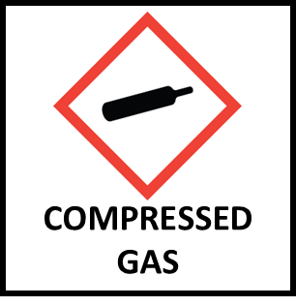
The COMPRESSED GAS label must be posted at access points to laboratories or storage areas regularly storing or using more than two compressed gas cylinders or lecture bottles.

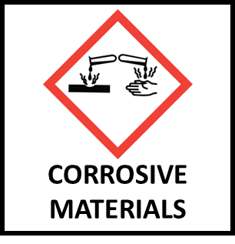
The CORROSIVE MATERIALS label must be posted at access points to laboratories or storage rooms containing 4 liters or more of corrosive substances (Category 1 Skin corrosion/irritation). Corrosive materials are capable of causing visible destruction of the skin, eyes, or the lining of the respiratory tract or the gastrointestinal tract on contact. These typically include materials with a very low pH (acids) or a very high pH (bases). Refer to safety data sheets to identify corrosive materials. NOTE: If chemicals are present in the lab which meet this posting requirement, then the Eye Protection Required pictogram must also be included and an accessible eyewash must be available in the lab which is flushed on a weekly basis. Weekly flushing of the eyewash must be documented on the Emergency Eyewash Maintenance Log, which must be posted near the eyewash.

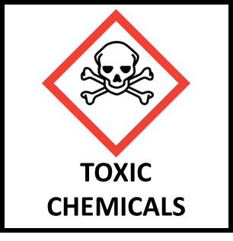
The TOXIC CHEMICALS or ACUTE TOXIC label must be posted at access points to laboratories or storage rooms containing chemical substances defined by the Globally Harmonized System of Classification and Labelling of Chemicals (GHS) as causing serious adverse health effects (i.e. lethality) occurring after a single or short-term oral, dermal, or inhalation exposure to a substance or mixture. The Occupational Safety and Health Administration (OSHA) further defines Acute Toxicity as substances causing adverse effects occurring following oral or dermal administration of a single dose of a substance, or multiple doses given within 24 hours, or an inhalation exposure of 4 hours. Storage shelves for acutely toxic substances should be clearly labeled TOXIC CHEMICALS. The thresholds for posting this symbol on the caution sign are:
- Any amount of Category 1 Acute Toxic, Oral substance
- Any amount of Category 1 or 2 Acute Toxic, Dermal or Inhalation substance

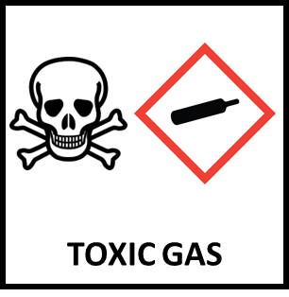
The TOXIC GAS label must be posted at access points to laboratories or storage rooms containing gases classified by OSHA as having Acute Toxicity due to causing adverse effects following an inhalation exposure of 4 hours. This posting is for gases classified by OSHA as either Category 1 or 2 Acute Toxicity, Inhalation. Refer to SDS to aid in identification.

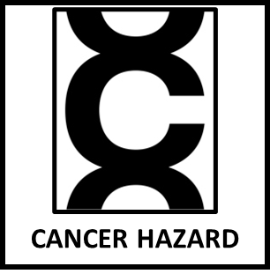
The CANCER HAZARD or CARCINOGEN label must be posted at access points to laboratories or storage rooms containing any amount of substances designated by OSHA as Carcinogenicity Category 1 - Known or presumed human carcinogens and those substances that are specifically regulated by OSHA as carcinogens (OSHA 29 CFR 1910.1003).

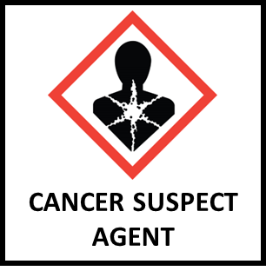
The CANCER SUSPECT AGENT label must be posted at access points to laboratories or storage rooms that use or store chemicals designated by OSHA as Carcinogenicity Category 2 - Suspected human carcinogens or those substances classified by the International Agency for Research on Cancer (IARC) or National Toxicology Program (NTP) as known or suspected human or known animal carcinogens.

Biosafety Labels and Signs

Federal and state regulations and WSU policies require posting of labels and signs in areas where infectious agents or materials may be present to warn personnel and visitors of biological hazards. Specifically:
OSHA 1910.145(e)(4)
The biological hazard warning shall be used to signify the actual or potential presence of a biohazard and to identify equipment, containers, rooms, materials, experimental animals, or combinations thereof, which contain, or are contaminated with, viable hazardous agents. For the purpose of this subparagraph the term "biological hazard," or "biohazard," shall include only those infectious agents presenting a risk or potential risk to the well-being of man.

Figure 3: Biohazard label.
Biohazard labels (Figure 3) that are fluorescent orange or orange-red must be affixed to waste containers; refrigerators and freezers; incubators; equipment used in procedures involving biohazard materials; and other containers used to store, transport or ship infectious agents, human blood, or other potentially infectious materials. These labels can be obtained from OEHS, purchased from a safety sign company, or printed (in color) by the laboratory.

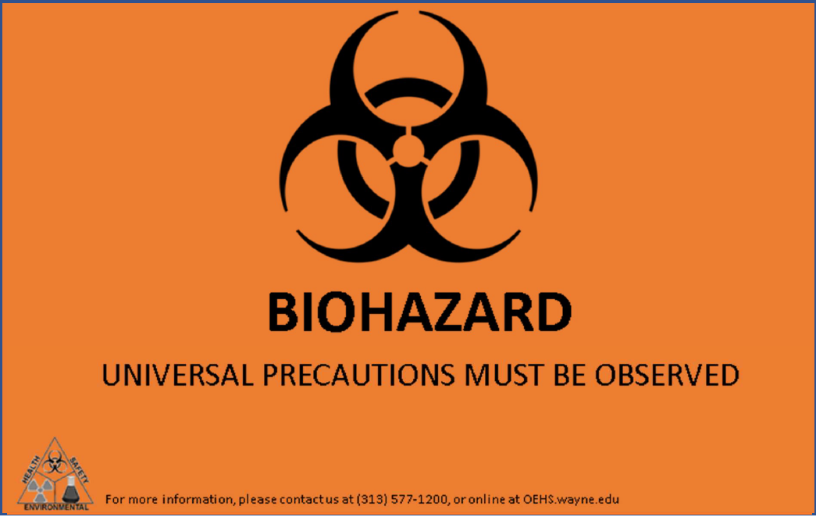
Figure 4: Universal Precautions Sign
The Universal Precautions Sign (Figure 4) shall be posted on the door or immediately adjacent to the door where human and non-human primate cell lines, tissues, blood, or other potentially infectious materials are worked with or stored. This sign should be posted at the main lab entrance if work with the above materials occurs throughout the main lab. If work and storage is confined to an interior room, the sign should be posted at the entrance to the interior room only. This sign can be obtained from OEHS.
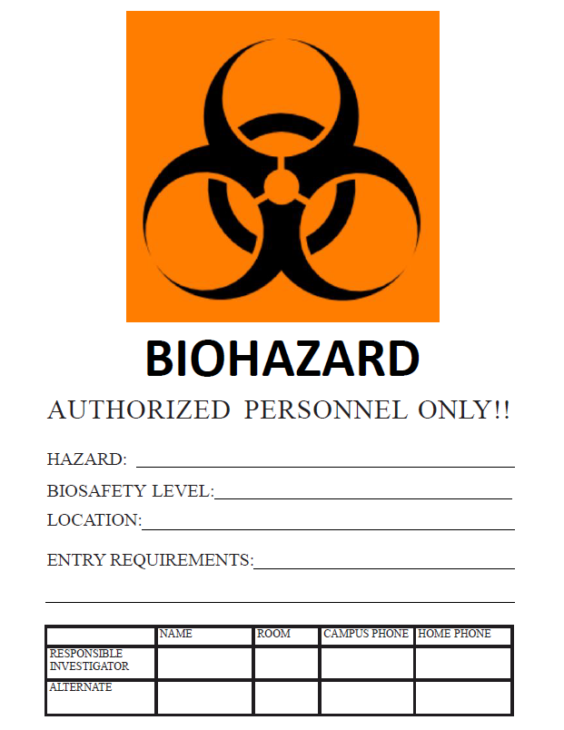
Figure 5: Full Biohazard Sign
The Full Biohazard Sign (Figure 5) shall be completed and posted on the door or immediately adjacent to the door where specific risk group 2 organisms or inactivated Select Agents, risk group 3, or risk group 4 organisms are being used or stored. The Hazard section must include the name of the specific agent(s) present. Emergency contact information must be included on this door sign, in addition to what is listed on the Laboratory Caution sign. This sign should be posted at the main lab entrance if work with the organism(s) occurs throughout the main lab. If work and storage is confined to an interior room, the sign should be posted at the entrance to the interior room only. This sign can be obtained from OEHS.

Other Safety Warning Signs

Laboratory spaces may require additional safety signs posted outside or within the laboratory. Required signage is dependent on the hazard(s) present and relevant federal and state regulations. Personnel should consult with OEHS to determine appropriate signs and placement if any of the conditions below exist in their laboratory space, and where signs may be purchased or obtained. Laboratory personnel should also be aware of the meaning of these signs when considering entering areas not assigned to their laboratory group.

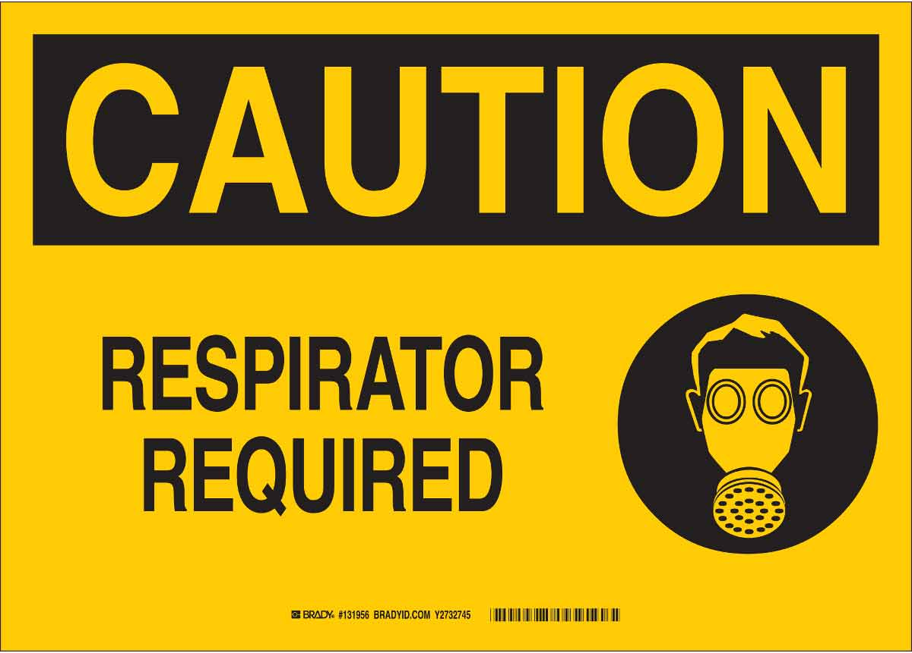
The RESPIRATORY PROTECTION sign must be posted at access points to laboratories where breathing air is contaminated with harmful dusts, fogs, fumes, mists, gases, smokes, sprays, or vapors above permissible exposure limits and is not being ventilated by an appropriate local exhaust system (e.g., a chemical fume hood). THIS IS TYPICALLY A TEMPORARY POSTING FOR UNIQUE SITUATIONS AND SHOULD INCLUDE A “DO NOT ENTER” WARNING. Whenever feasible, all work involving harmful dusts, fogs, fumes, mists, gases, smokes, sprays, or vapors above permissible exposure limits should be conducted inside a chemical fume hood (or other appropriate local exhaust system) instead of relying on a respirator for protection. Respiratory protection caution signs can be found and downloaded from the internet, to be printed in color.

Some of the signs shown below are for areas using non-ionizing radiation such as lasers and MRI’s. Visit the OEHS Non-Ionizing Radiation webpage for information on regulatory requirements and university policies regarding registration and use.

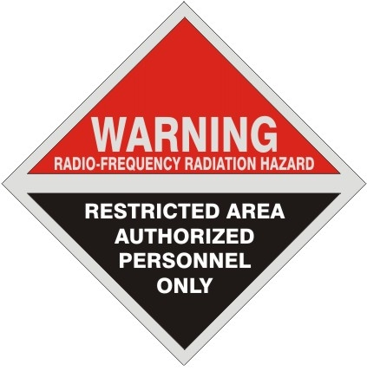
The RADIO FREQUENCY sign is required when the potential for personal exposure to electromagnetic radiation within the frequency range of 10 MHZ to 100 GHz exceeds a power density of 10 mW/cm2 averaged over a six-minute period. For more about the hazards of non-ionizing radiation, refer to OEHS and OSHA 29 CFR 1910.97 - Nonionizing radiation.

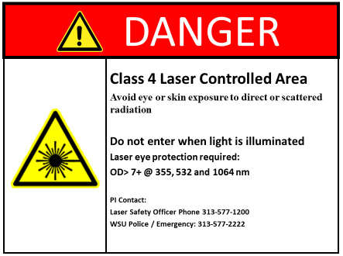
The DANGER LASER CONTROLLED AREA sign must be displayed on the outside of the access points to each laboratory where Class IV (4) lasers are in operation at or above 1 kilowatt (1000 Watts).

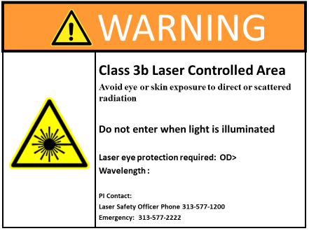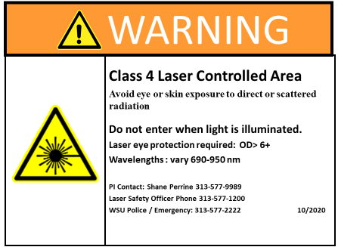
The WARNING LASER CONTROLLED AREA signs must be displayed on the outside of the access points to each laboratory where Class IV (4) or class IIIb (3B) lasers are in operation at less than 1 kilowatt of power.

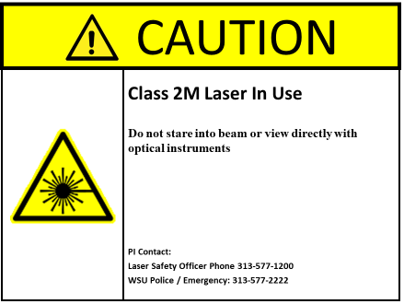
The CAUTION LASER IN USE sign must be displayed on the outside of access points to each laboratory where Class IIIA (3R) and II (2, 2M) lasers are in operation.

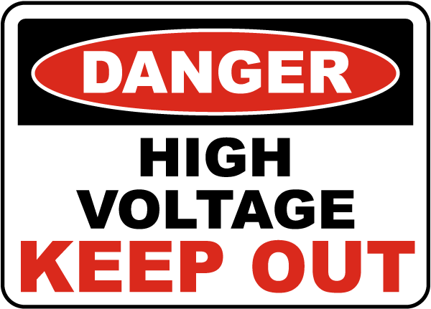
The HIGH VOLTAGE – KEEP OUT sign is required for areas containing exposed live parts or exposed conductors operating at or over 600 volts, nominal. Access to these areas must be limited to qualified persons or by persons accompanied and authorized by a qualified person. A “Qualified person” is defined as one who has received training in and has demonstrated skills and knowledge in the construction and operation of electric equipment and installations and the hazards involved (OSHA 29 CFR 1910.399).

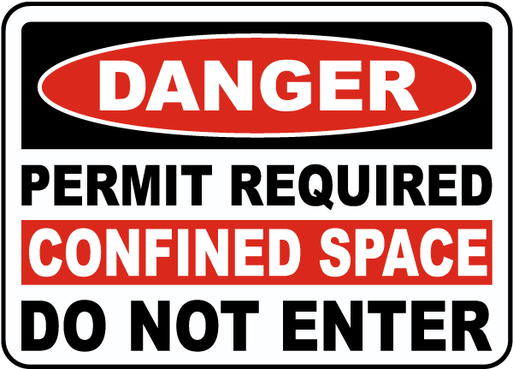
The PERMIT REQUIRED CONFINED SPACE sign is required to identify a space that:
- Is large enough and so configured that an employee can bodily enter and perform assigned work; and
- Has limited or restricted means for entry or exit; and
- Is not designed for continuous employee occupancy; and
- Has one or more of the following hazard characteristics:
  - Contains or has a potential to contain a hazardous atmosphere;
  - Contains a material that has the potential for engulfing an entrant;
  - Has an internal configuration such that an entrant could be trapped or asphyxiated by inwardly converging walls or by a floor which slopes downward and tapers to a smaller cross-section; or
  - Contains any other recognized serious safety or health hazard.

No WSU employee may enter a space marked with this sign without permission from the authorized agent responsible for the space. Contractors must utilize an appropriate confined space entry procedure. For more information about confined space safety and entry requirements, refer to OEHS and OSHA 29 CFR 1910.146 - Permit-required confined spaces.

Outdated CAUTION Placard Symbols

In 2023 OEHS updated the hazard pictograms to be used on the yellow CAUTION placard posted outside of laboratory doors. Some placards across campus may still have the older pictograms posted. The outdated pictograms are shown below as reference.

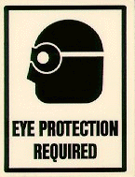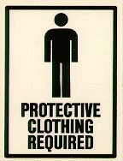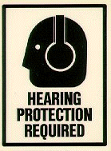

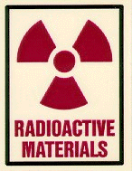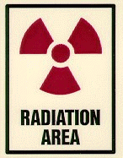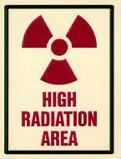
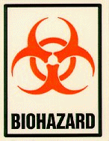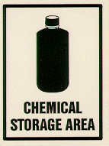
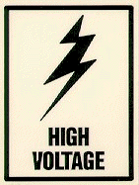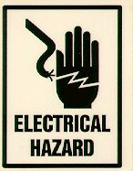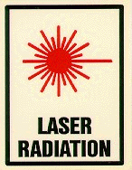
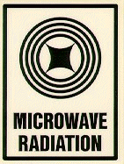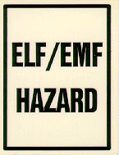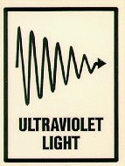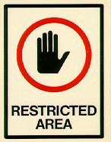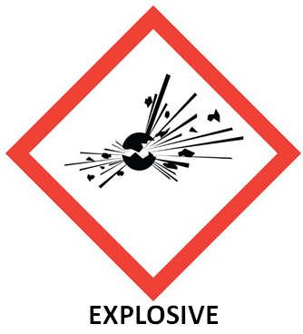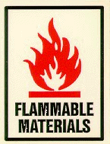
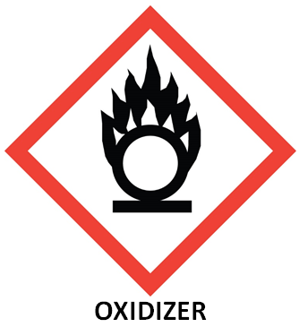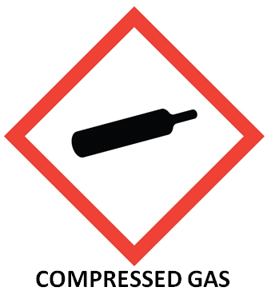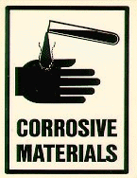
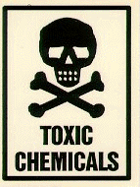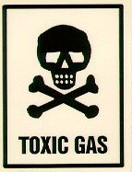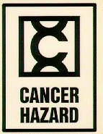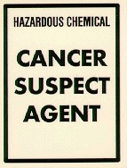

References

- OSHA 29 CFR 1910.145 - Specifications for accident prevention signs and tags
- MIOSHA Part 37 - Accident Prevention Signs and Tags
- OSHA 29 CFR 1910.1030(g)(1) Bloodborne pathogens – Labels and signs
- 1910 Subpart Z - Toxic and Hazardous Substances
- OSHA 29 CFR 1910.1003 – 13 Carcinogens
- OSHA 29 CFR 1910.1200 App A - Health Hazard Criteria
- OSHA 29 CFR 1910.1200 App B - Physical Criteria

