**Safe Use of a Bunsen Burner**

If using a Bunsen burner in a biological safety cabinet, see: [Use of Natural Gas in Biosafety Cabinets](https://research.wayne.edu/oehs/pdf/gas-in-bsc.pdf)

For video instruction: [YouTube video on lighting a Bunsen burner](https://www.youtube.com/watch?v=zIP-gg5SDLE)

# Prior to Lighting Bunsen Burner:

* Know the location of the laboratory’s main gas shut off valve and fire extinguisher.
* Place the Bunsen burner away from any overhead shelving, equipment, or light fixtures by at least 12 inches.
* Remove all papers, notebooks, combustible materials, and excess chemicals from the area.
* Tie-back any long hair, dangling jewelry, or loose clothing.
* Use correct tubing (butyl rubber hose). Inspect hose for cracks, holes, pinch points, or any defect and replace if necessary. Check the hose fits securely on the gas valve and the burner.
* Notify others in the lab that the burner will be in use.

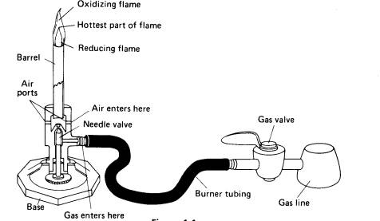

## Lighting Bunsen Burner:

* Before turning on gas, have a sparker/lighter with extended nozzle to ignite burner. Never use matches.
* Check connections to burner and desk outlet valve.
* Close needle valve and collar.
* Open gas valve fully.
* Open needle valve 1/2 turn.
* Use the spark/lighter to light the flame.
* Adjust flame by turning the collar to regulate air flow and produce an appropriate flame for the experiment (typically a medium blue flame).

### During Use:

* Never leave a lighted burner unattended. Drafts (including those created by a hood) may extinguish the flame, but the gas will still be on. This could result in an explosion.
* Never face the vessel (test tube, beaker, etc.) being used to heat a material toward yourself or others near the burner. In some experiments, a hot plate should be used instead.
* A hot plate or heating mantle must be used when flammable liquids are to be heated.

### After Use:

* Items will be very hot. Do not touch with your bare hands unless the air near it feels cool.
* Use crucible tongs or thermal gloves to handle hot items. Do not set hot items on paper; it might catch fire. Let the apparatus cool in place, with the burner removed or extinguished.
* Shut off gas when its use is complete.
* Allow the burner to cool before handling.