GLOVE SELECTION GUIDE

INTRODUCTION
The Occupational Safety and Health Administration (OSHA) standard regarding personal protective equipment (PPE) for hand protection (29 CFR 1910.138) mandates:
- Employers shall select and require employees to use appropriate hand protection when employees' hands are exposed to hazards such as those from skin absorption of harmful substances; severe cuts or lacerations; severe abrasions; punctures; chemical burns; thermal burns; and harmful temperature extremes.
- The selection shall be based on an evaluation of the performance characteristics of the hand protection relative to the task(s) to be performed, conditions present, duration of use, and the hazards and potential hazards identified.
Each lab must conduct a hazard assessment to identify the risks to personnel hand safety and to identify the best controls to provide hand protection. This includes assessing individual procedures when designing experiments. Based on the results of a hazard assessment, a lab may need to purchase more than one type of glove and/or use other means of protection in addition to the gloves to protect personnel from the various hazards present.

HAZARD ASSESSMENT
Conduct a hazard assessment to identify the hazardous properties of the chemicals used and other hazards (e.g. physical, biological) that might be present during a task or job which requires hand protection. A hazard assessment is critical for selecting the appropriate chemical resistant or other glove type based on material, thickness, length and other traits (e.g., cut resistance). Factors which aid the hazard assessment and influence the glove selection include:
- Chemical type (e.g. corrosive, toxic, flammable etc.) – Review SDS for hazard class(es) and severity.
- Concentration of the chemical
- Physical hazards (temperature, sharps, piercing objects, etc.)
- Biological hazards
- Frequency and duration of contact with the hazard
- Nature of contact with the hazard – total immersion or splash only
- Length to be protected – hand, forearm, arm

BEST PRACTICES
- Always conduct a hazard assessment.
- When feasible, employ engineering controls to eliminate or reduce hazard exposure to hands.
- Whenever possible, it is recommended to substitute highly hazardous chemicals with less hazardous chemicals.
- Refer to chemical specific SDS – Section 8 for PPE recommendations. The links in the References section of this document are also excellent resources for identifying appropriate glove material. The manufacturer of the chemical or the gloves may also be able to provide recommendations.
- Glove selection guides are specific to “pure” chemicals. For chemical combinations, base glove selection on the component with shortest breakthrough time. See references below for links to guides.
- Gloves are available in various thicknesses, which can provide some additional protection. Many highly hazardous chemicals may require the use of thicker gloves.
- Depending on job hazards, it may be appropriate to double glove (same or different glove types). For example, thermal protection or cut resistant gloves may be needed over disposable gloves. Double gloving of the same type of glove will provide some additional chemical/biological protection in case of minute holes (pinhole leaks) which are difficult to detect with the naked eye.
- Prior to wearing gloves, inspect for any signs of degradation or puncture.
- While wearing gloves, to prevent contamination, avoid touching yourself, clothing, non-essential equipment, phones, wastebaskets or other surfaces.
- When removing gloves, to avoid accidental skin exposure, remove the first glove by grasping the cuff and peeling the glove off the hand so that the glove is inside out. Repeat this process with the second hand, touching the inside of the glove cuff, rather than the outside.
- After removing gloves, wash hands immediately with soap and water.
- Disposable gloves should be changed when there is any sign of contamination or damage.
- Change disposable gloves frequently. Temperature, chemicals handled, and tasks can cause disposable gloves to degrade (increasing permeability) and more likely to sustain holes or tears.
- Chemically contaminated disposable gloves should not be placed in regular trash, but should be disposed of as hazardous solid chemical waste.
- Reusable gloves should be cleaned frequently following manufacturer’s instructions.

DISPOSABLE VS. CHEMICAL RESISTANT GLOVES
- Disposable gloves have minimal chemical resistance and relatively short break-through times. These are recommended for incidental contact (i.e. splashes). Gloves that are between 4-8 mils thick are typically considered disposable.
- Chemical resistant gloves are suitable for extended chemical contact (i.e. immersion) and for highly hazardous chemicals. These types of gloves are typically >8mils thick.

REFERENCES
MANY OF THE LINKS BELOW ARE TO GLOVE SELECTION GUIDES/TABLES USEFUL FOR IDENTIFYING APPROPRIATE GLOVES.
- Ansell Guardian Chemical Protection Interactive Guide.
- VWR Handy Solution Guides. (December 2019).
- VWR North Safety Hand Protection Chemical Resistance Guide. (December 2019).
- Recommendations for Chemical Protective Clothing Database. National Institute for Occupational Safety and Health (NIOSH).
- OSHA Personal Protective Equipment Guide 3151. (2004)
- Grainger Quick Tips #191: Chemical Protective Gloves. (January 2019).
- Grainger Quick Tips #301: Cut-Resistant Glove Selection and Use. (January 2019).
- Grainger Quick Tips #394: Choosing the Right Disposable Glove. (December 2015).

Glove material | Intended use | Advantages and Disadvantages | Example Photos
Latex exam gloves | Incidental contact | Good for biological and water-based materials.  Poor for organic solvents.  Little chemical protection.  Hard to detect puncture holes.  Can cause or trigger latex allergies. | 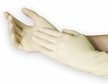
Natural rubber gloves | Extended contact (thicker reusable glove) | Good for water solutions of acids, alkalis, salts and ketones.  Can cause or trigger latex allergies. | 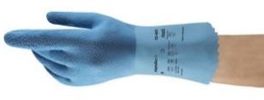
Nitrile | Incidental contact (disposable exam glove)  Extended contact (thicker reusable glove) | Excellent general use glove. Good for solvents, oils, greases, and some acids and bases.  Clear indication of tears and breaks.  Good alternative for those with latex allergies. | 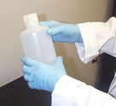
Butyl | Extended contact | Good for peroxide, rocket fuels, highly corrosive acids, strong bases, alcohols, aldehydes, ketones, esters and nitrocompounds.  Poor for aliphatic and aromatic hydrocarbons and halogenated solvents. | 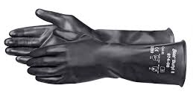
Neoprene | Incidental contact (disposable glove)  Extended contact (thicker reusable glove) | Good for hydraulic fluids, gasoline, alcohols, organic acids and alkalis.  Poor for halogenated and aromatic hydrocarbons. | 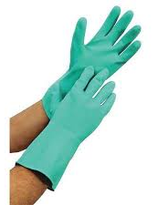
Norfoil | Extended contact | Good for most hazardous chemicals.  Poor fit (Note: Dexterity can be partially regained by using a heavier weight Nitrile glove over the Norfoil/Silver Shield glove. | 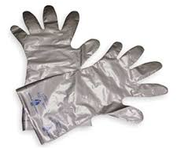
Viton | Extended contact | Good for chlorinated and aromatic solvents.  Good resistance to cuts and abrasions.  Poor for ketones.  Expensive. | 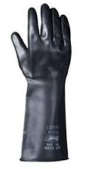
Polyvinyl chloride (PVC) | Specific use | Good for acids, bases, oils, fats, peroxides, and amines.  Good resistance to abrasions.  Poor for most organic solvents. | 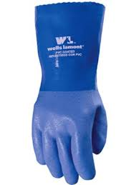
Polyvinyl alcohol (PVA) | Specific use | Good for aromatic and chlorinated solvents.  Poor for water-based solutions. | 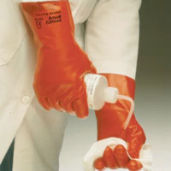
High Performance Poly Ethylene (HPPE)  Kevlar  Stainless steel  Leather | Specific use | Cut-resistant gloves. Ten levels of cut resistance based on the ANSI/ISEA 105-2016 standard.  Cut-resistant sleeves are also available to provide protection to wrists, forearms, or full arm.  (If potential for biological or chemical contamination: wear appropriate chemical protective gloves under cut-resistant gloves and discard after use). | 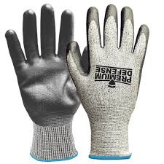  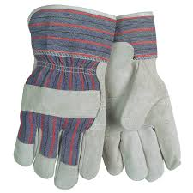
Cryogenic Resistant Material  Leather | Specific use | For use with cryogenic materials.  Designed to prevent frostbite. Note: Never dip gloved hands directly into liquid nitrogen. | 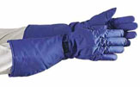
Heat Resistant  Terry-cloth cotton | Specific use | For use with autoclaved or other hot items  Designed to prevent burns. | 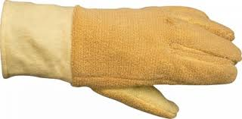
Leather  Aluminized Leather  Flame Resistant | Specific use | For welding.  Prevent burns and designed not to catch fire from welding sparks. | 