Dispensing liquid nitrogen requires:
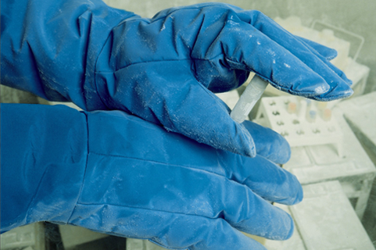 Proper cryogenic gloves
Goggles and face shield 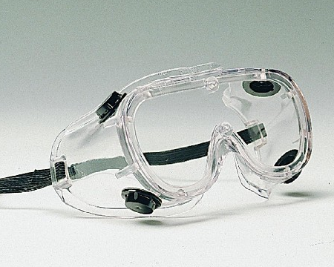 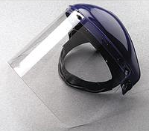
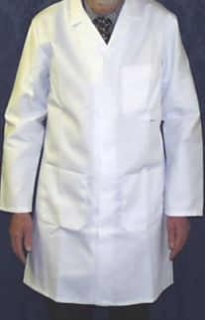 Lab coat, long pants, closed-toe shoes
Purchase proper PPE through the Science Storeroom: (313) 577-3098.
WSU Office of Environmental Health & Safety
(313) 577-1200

