ANNEX 2 – CLASSIFICATION FLOW CHART
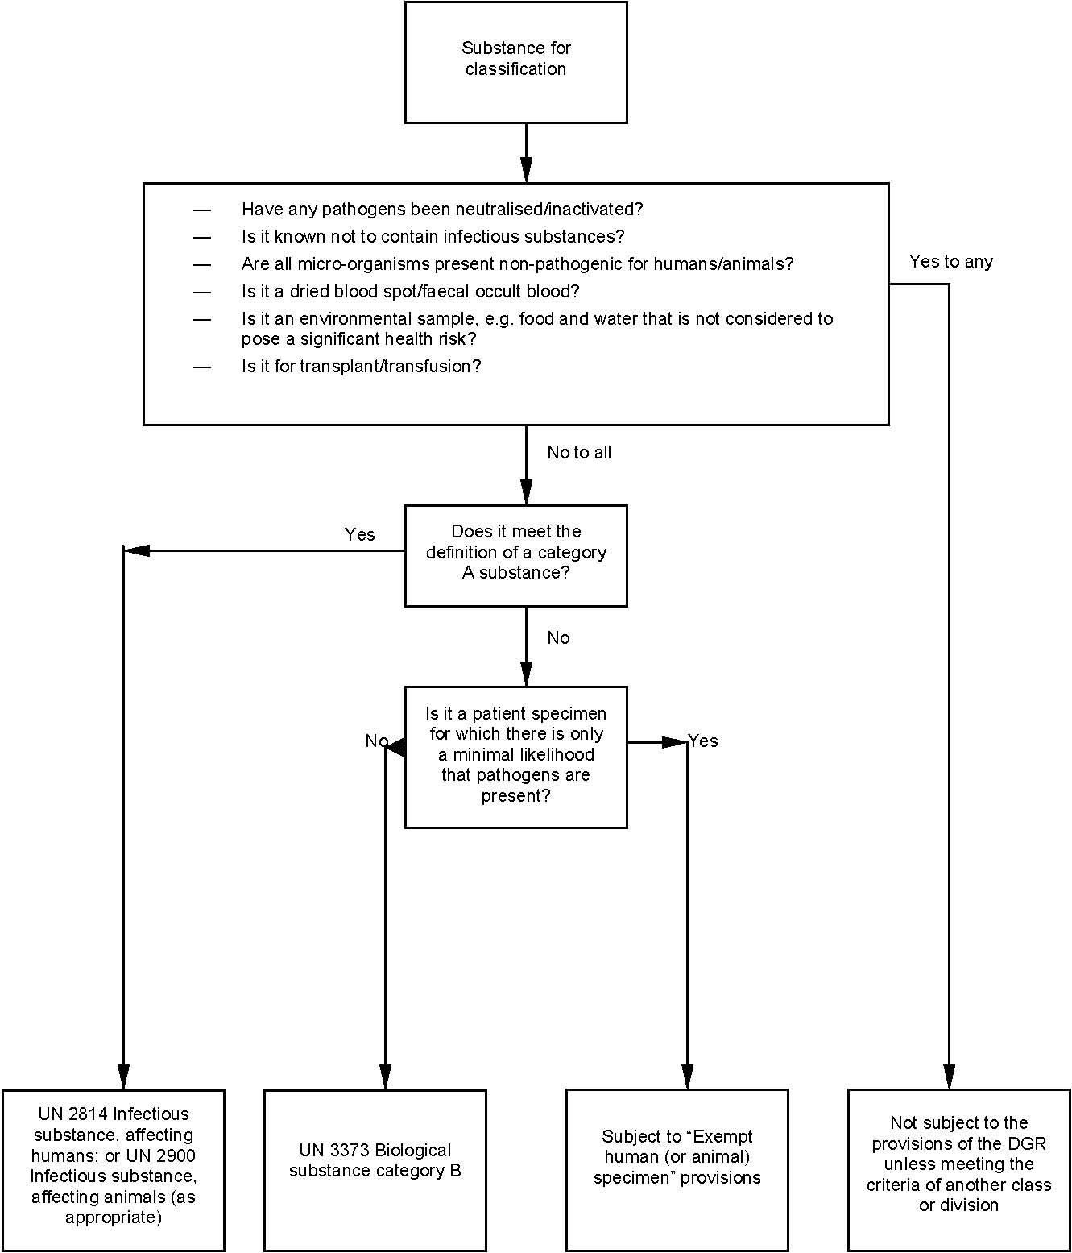
OEHS will ship.
Call (313) 577-1200
Training Required for Shipping Dry Ice
& Biological Substance Category B
*DGR = Dangerous Goods Regulations

