Wayne State University: iLab Institution Manual

Contents
Overview 2
Logging into iLab: 2
Switch to New Design: 4
Navigating iLab: 5
View Requests: 5
Institution Dashboard: Wayne State University 6
Summary of Cores 6
User Management 7
Pending Lab Access Request 7
Research Groups 7
Index Number 9
Manage Research Groups (Labs) & Index Number 10
Accessing your Lab 10
Managing Members and Index Number in a Lab 11
Managing Members of your Group 11
Accepting a member into your lab 11
Assigning Index Number to Members of a Lab 12
Requesting Access to Non-sponsored Index Number 12
Custom Billing Fields 14
Navigating to Core Default Custom Billing Fields: 14
Navigating to Service Level Custom Billing Fields 15
Navigating to Equipment/Calendar Level Custom Billing Fields 16
Filling out Custom Billing Fields: 16
Billing Process 17
Invoices: 18
iLab Help Site 18

Overview

The iLab/Wayne State University Financial Integration allows PIs, Financial Managers, Researchers and Core Managers to use valid payment information Index Number at each step of the request and billing process for core facilities. PI’s and/or lab managers assign Index Number to individuals who will utilize Wayne State University cores. Researchers can order services using Index Number and core managers can bill for these services knowing that they are using valid Index Number. This document can be used by institution admins, PI’s, lab managers, and core staff as a guide for using iLab. This document will review logging into and navigating iLab, assigning Index Number and making any appropriate changes to labs. For an overview of iLab terms, click here.

Logging into iLab:
The iLab/Wayne State University ID SSO integration allows for internal users to seamlessly register and login to iLab using their Wayne State University credentials. For external registration instructions, click here.

Registration Process for Internal Users

- Navigate to the following URL: https://waynestate.ilab.agilent.com/account/login
- Bookmark this URL for future use.
- Once on the iLab login page, select ‘Wayne.’
- At this point you will be prompted to provide your Wayne State and password.

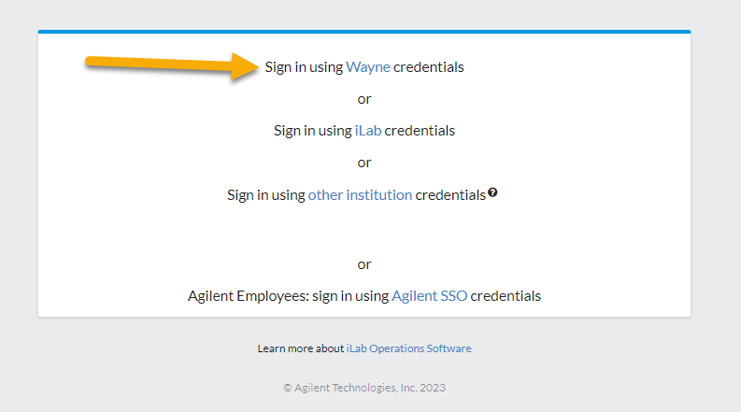

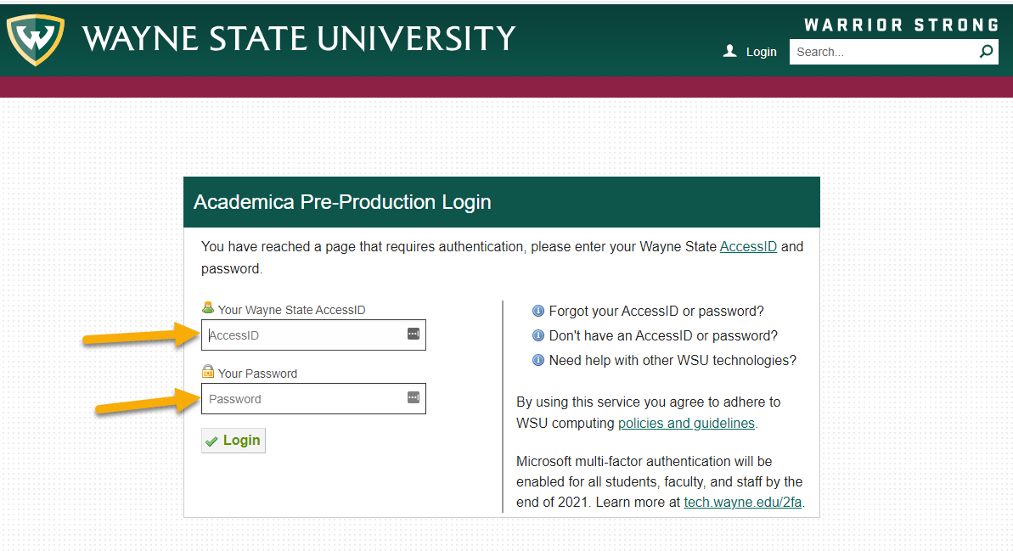

  - If this is your first time logging in, once you authenticate you will be directed to a registration page.
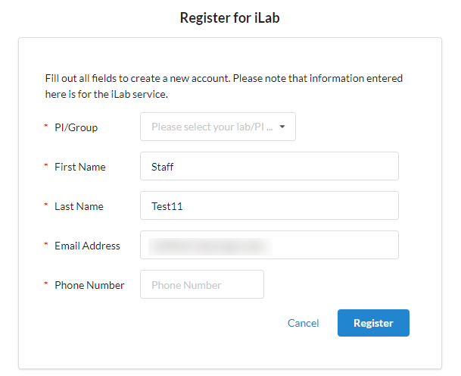
- First select the appropriate PI/Group from the first drop down.

- Your first name, last name, and email address will be pre-filled. Complete any remaining required fields.
- Click ‘Register.’ The next page you see will be the ‘Greeting Page’
- The PI you selected has been sent an email informing them that they need to approve your account.

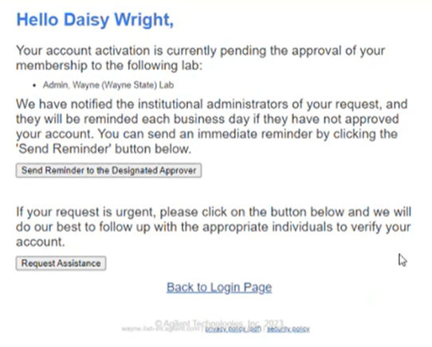

- The PI is reminded each business day but you have the opportunity to send an additional reminder.
- You will also receive a Welcome email with brief getting started instructions.
- Once your account has been approved you will receive an email notifying you.
- Now you can login following steps 1-4 to utilize the core facilities within iLab
- Once logged in you will be on the iLab homepage dashboard. Make sure to set your time zone!

Switch to New Design:
Your account may be in the old design, the first step is switching to the new design!
- Click the ‘Try new design!’ link at the bottom of your screen near the iLab Agilent trademark.
- Your page will refresh automatically and when you navigate to your institution dashboard it will be in the new design.
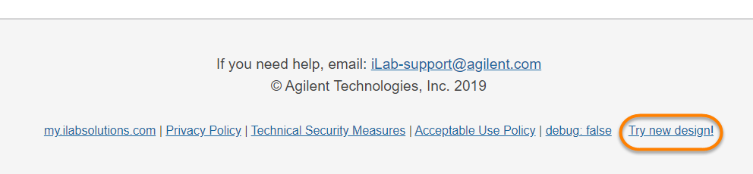

Navigating iLab:
The left-hand navigation panel will be used to navigate through iLab functionality. To view additional information about overall iLab navigation, click here.

Image 1.1: Core Facilities:
- Click ‘Core Facilities’ to see any live Wayne State University cores.
- You can also search for core facilities outside of Wayne State University.
Image 1.2: View Requests:
- Click ‘View Requests’ to see a list of requests per core. This area is where a PI/Lab Manager can approve/deny requests or provide an Index Number(s).
- Only available for Institution admins, PIs, and lab managers.
Image 1.3: My Groups
- Click ‘My Groups’ to see a list of the labs in which you manage.
Image 1.4: Wayne State University:
- This link is ONLY available to those with an Institution Admin/Financial Admin membership.
- Click this link to access the Institutional Dashboard which includes a full list of cores (live and in development), Institution memberships, full list of internal labs, and a full list of Index Number.

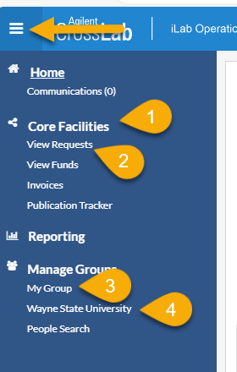

View Requests:
‘View Requests’ allows you to see a list of requests per core. This area is where a PI/Lab Manager can approve/deny requests or provide a Index Number(s). This section is only available to Institution Admins, PIs, and Lab Managers. For additional information on the ‘View Requests’ page, click here.

- Click ‘View Requests’ to see all requests.
- Use the tabs along the top to navigate between requests.
  - Awaiting Approval: Displays any request made by a researcher from your lab to a core that has exceeded the pre-approved cost that the lab has set. This request now requires approval from a financial manager to proceed with the service request. Simply click ‘Agree’ or ‘Disagree’.
  - Require Payment Info: Displays any request made by a researcher that does not have a Index Number selected to charge.
    - To update, simply click the $ icon and select a Index Number. Click save.
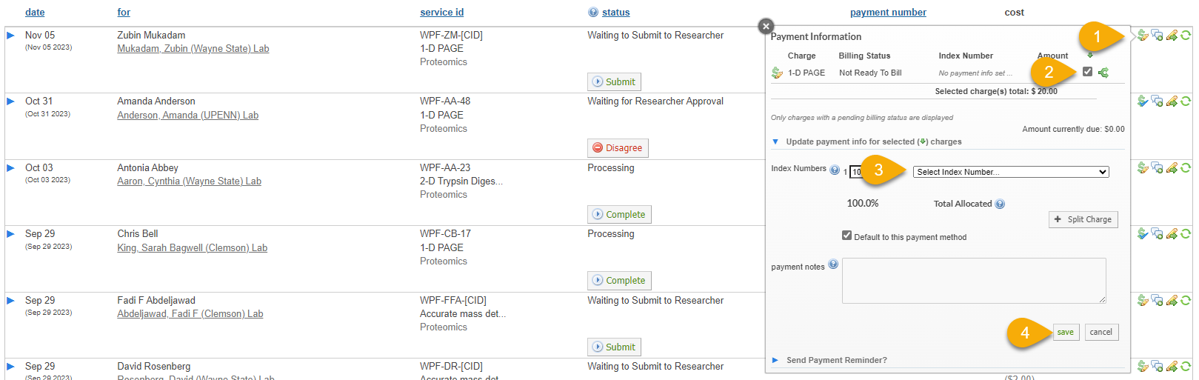
  - Processing and Recently Completed: Displays all current or recently finished request from any researcher within your lab(s) that does not require actions.
  - All Requests: Display all requests from anyone within your lab.

Institution Dashboard: Wayne State University
The institution dashboard is accessible by institution admins, institution financial managers, and institution managers. You can navigate to your institution dashboard by clicking the ‘Wayne State University’ link in the left-hand menu. On your dashboard you can view a summary of cores, manage users and Index Number, view billing events across all cores, run reports at the institution level, and adjust settings. For additional information on the institution dashboard, click here.

Summary of Cores
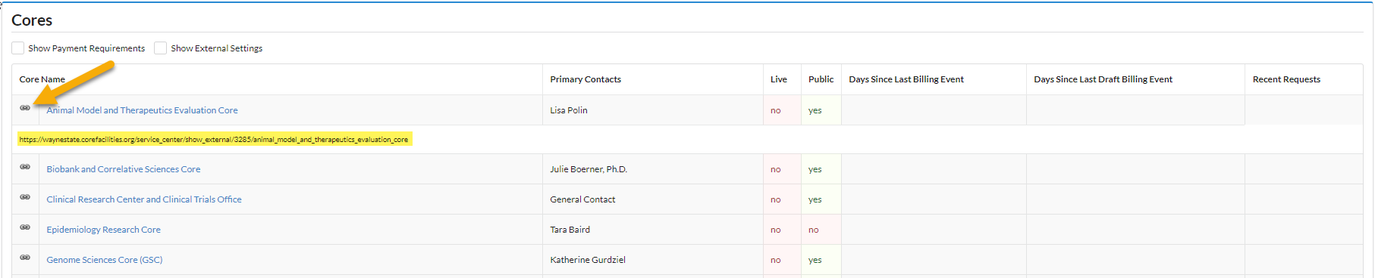
On the ‘Summary of Cores’ tab you can view all cores at Wayne State University that are live, in development, and details about the core. Each core name is a hyperlink which will take you to the core. There is also a link icon to the left of the core’s name which will provide you with the custom URL for that core. For additional information about the ‘Summary of Cores’ tab, click here.

User Management
On the ‘User Management’ tab you can view and manage pending lab access requests, research groups (labs), memberships to Wayne State University, and Index Number. For additional information about the ‘User Management’ tab, click here.

Pending Lab Access Request
The ‘Pending Lab Access Request’ will appear only when a new internal user registers for an iLab account or is requesting access to a new/additional lab. The grey number on the ‘User Management’ tab indicates the number of outstanding requests. PIs and/or Lab Managers will act on these requests within their lab. An institution admin can act on these requests on this dashboard.
- The black bolded name is the lab the user is requesting access to, typically the PI’s name.
- Below the lab name is the name of the user requesting access.
- Hover over the user’s name to display action buttons.
  - Accept: If the user is part of the lab selected, click ‘Accept’ to add them into the lab.
  - Change Lab: If the user is not part of the lab selected but their correct lab is in iLab, select ‘Change lab.’
  - Reject: If the user is not part of any lab within iLab.
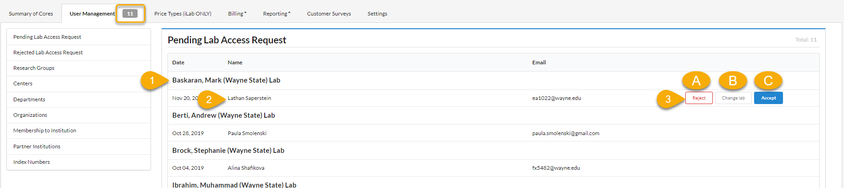

Research Groups
Research Group, also known as labs, is a central location for a PI, their researchers, and Index Number. The PI and lab manager can manage the researchers and assign Index Number within the lab. The labs in this section are created through the fund file that Wayne State University sends iLab nightly. The name of the lab is a hyperlink to the lab. For additional information on managing a Research Group navigate to the Manage Research Groups (Labs) & Projects section of this document.

Manually Creating a Lab:
There may be scenarios where a PI does not come through in the nightly fund file but they need an account and lab within iLab. The PI will need to register in iLab first and their lab will need to be manually created by an Institution Administrator.
- It is important to first confirm that the PI does not have a lab in iLab because you do not want to create a duplicate lab.
  - On the ‘User Management’ tab within the ‘Research Group’ section search for the PI.
  - If the PI’s lab exists, do not proceed with creating a lab.
  - If the PI’s lab does not exist, you can proceed.
- The PI must register before you can create the lab.
  - When the PI is registering, they will select to be in the Admin (Wayne State) Lab
- Click ‘Wayne State University’ in the left-hand panel.
- Navigate to the ‘User Management’ tab.
- Accept the PI into the Admin (Wayne State) Lab.
  - Hover over the PI in the ‘Pending Lab Access Request’ section.
  - Select ‘Accept.’
- Scroll down to the Research Groups section.
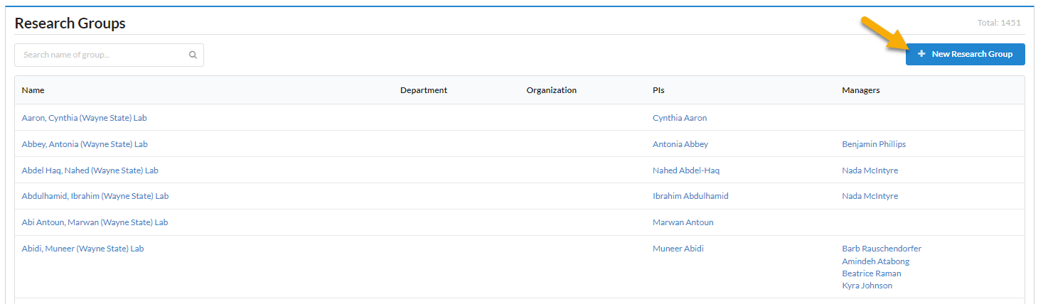
- Click ‘New research Group.’

- Name the lab.
  - Format should always be Last Name, First Name (Wayne State) Lab.
- Sharing should remain on stealth.
- In the ‘Select Existing’ text box, type the PI’s name.
- Click ‘Save.’
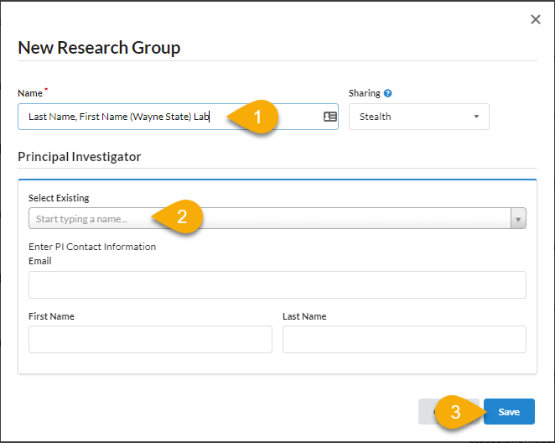

- Navigate to the Admin (Wayne State) Lab and remove the PI.
  - Click the trash can icon next to the PI on the ‘members’ tab.
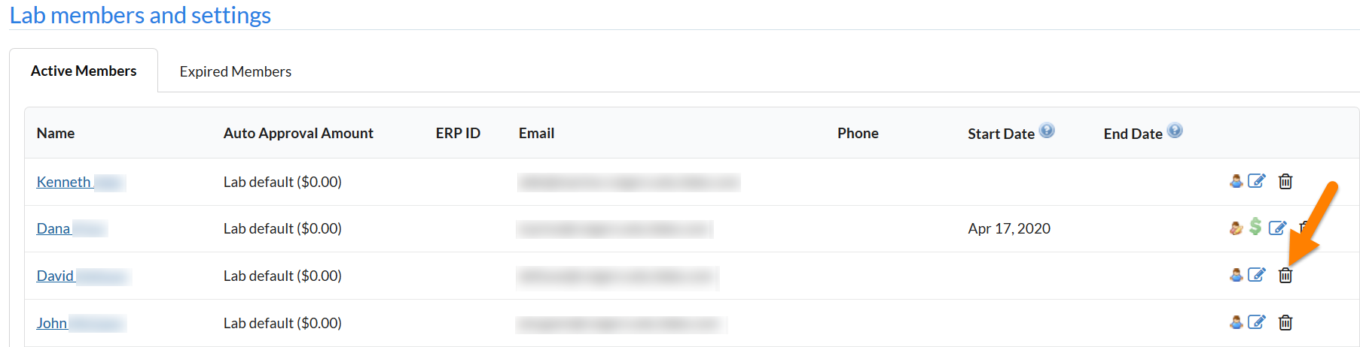

- Navigate to the PI’s lab and check that the PI is listed as the PI.
  - In the PI’s lab on the ‘Members’ tab hover over the person icon.
  - If any edits need to be made, click the blue edit pencil icon.

Index Number
Wayne State University sends iLab a nightly fund file which contains Index Number and the owners of those Index Number. The Index Number section will list all projects that are in iLab or were included in a fund file at one point. You can use the search feature to search for a specific Index Number. This is a great tool for troubleshooting. Below is a description of each column within this section.
- Index Number: This Index Number is passed to iLab from Wayne State University.
- Status: Will be either ‘active’ or ‘inactive.’
  - Active means the Index Number is currently in the last fund file iLab successfully loaded.
  - Inactive means that at one point that Index Number was sent to iLab in the nightly file but is no longer in the file.
- Created On: This is the date the Index Number first appeared in the nightly file that was successfully loaded into iLab.
- Updated On: Tracks the date iLab made the very last change to the Index Number within iLab.
  - For example, if the Index Number’s expiration date changes in lasts nights file, that date would be last night.
  - If the status is inactive, this updated on date is a good indicator of the first day we no longer saw that Index Number in the file.
- Expires On: This date will match the expiration date that is sent to iLab for that fund in the file.
  - If the Index Number is inactive, and the expiration date shows a date in the future, all that means is that the Index Number was removed from the file before it expired.
- Lab: A lab will be listed if that Index Number is present in a PI’s lab grid.
  - One thing to note is if the PI disables the Index Number using the ‘Disable/Enable Fund’ section in the lab, that Index Number will show as ‘Not in any lab’ even though it was just disabled.
For information about the Billing, Reporting, and Settings tabs on your institution dashboard, follow the links below.
- Billing: The billing tab will show all billing events across all cores at Wayne State University.
- Reporting: You can run reports across Wayne State University.
- Settings: There are some settings that an institution admin has access to.
- External Customer Numbers: A unique identifier given to external institution or group for billing purposes called a Vendor ID.

Manage Research Groups (Labs) & Index Number
Research groups are the PI’s lab where their members and Index Number live and are managed. Through a nightly fund file provided to iLab by Wayne State University, a list of PIs and Index Number are loaded and updated. PIs within this file will have their account and lab created automatically with all Index Number they are an owner of populated in their lab. If an Index Number is marked as a Non-Sponsored Index Number it will live in the background till it is requested into a lab. For additional information on managing groups, click here.
Note: This section will be in the PI and Lab Manager perspective, but institution admins have the same capability across all labs.

Accessing your Lab
- Click ‘My Groups’ in the left-hand navigation panel to see a list of labs you manage.
- Click the lab name to access the lab to adjust settings, members, and Index Number assignments.
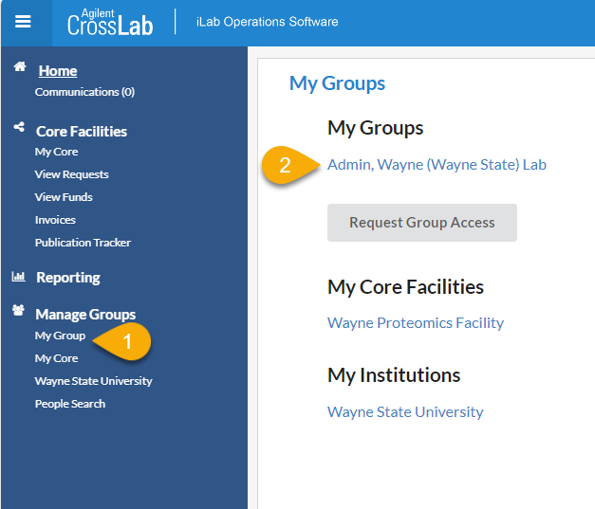

As a Principal Investigator (or, if delegated, a Lab Manager), you have a few new responsibilities to allow your researchers to order services from the cores and make equipment reservations. Specifically,
- Accepting users into your lab
- Assigning Index Number(s) to lab members
- Managing lab members
- Approving service requests and reviewing/providing payment information

Managing Members and Index Number in a Lab

Managing Members of your Group
Below are links to helpful articles on managing your group and members.
Overview of managing a group
Managing members: This will show you how to up change a member’s role, add expiration dates, and remove user
Update group membership: If you have a user who needs access to your lab and already has an iLab account they can request access using the linked article

Accepting a member into your lab
- Navigate to your lab.
- Click the ‘Membership Requests & Index Number’ tab.
  - This will show any pending membership request.
- Approve or reject the membership request.
  - If a researcher selected the incorrect lab, an institution admin can choose ‘change lab’ to update membership.
- After approving the member’s account, assign Index Number(s) to the new member.
  - A user cannot utilize a core facility unless they are assigned a Index Number.
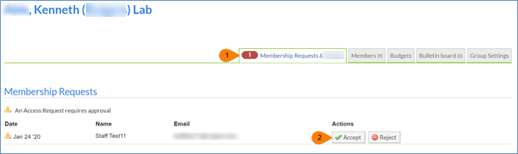

Assigning Index Number to Members of a Lab
The ‘Manage Index Number’ section will include a grid of all members that have been given access to your lab and Index Number that you are the owner of. For core facilities to bill for services, the user must be assigned a Index Number. If the Index Number needed for a lab member to charge services against does not exist in the grid, they can be requested through the ‘Request access to additional Index Numbers’ workflow.
- Within your lab navigate to the ‘Membership Requests & Index Number’ tab.
- In the ‘Manage Index Number ’ section click on the appropriate check box to assign a member a Index Number.
- Assign the appropriate Index Number (s) to each member on the list.
- When the box turns green that means the information has been applied to the member.

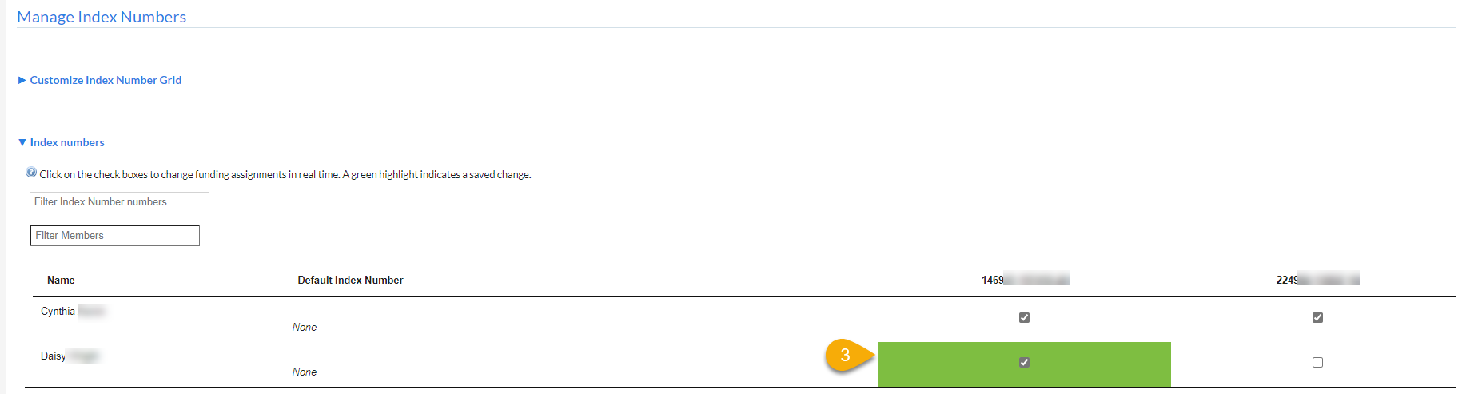

Requesting Access to Non-sponsored Index Number

Institution admins, PIs, and Lab Managers can request access to a non-sponsored Index Number. A non-sponsored Index Number comes through in the nightly fund file with an identifier that it is non-sponsored. These Index Number live in the background within iLab waiting to be requested into a lab.

- Navigate to your lab.
- On the ‘Membership Request & Index Number’ tab expand the section below the Index Number Grid called ‘Request access to additional Index Number.’
- Enter the Index Number within the text box
- Click ‘Request.’
- If the Index Number is valid a request will be sent to the fund owner to approve.
- If the Index Number is not valid an error message will appear.
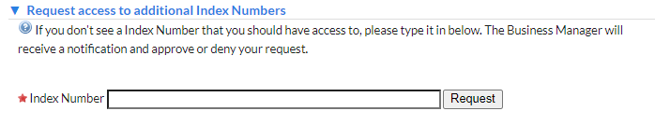

Managing Non-Sponsored Index Number Requests
Institution Admins, PIs and/or Lab Managercan request access to Non-Sponsored Index Number within their lab. When requesting access, the owner of that Index Number must approve the request.
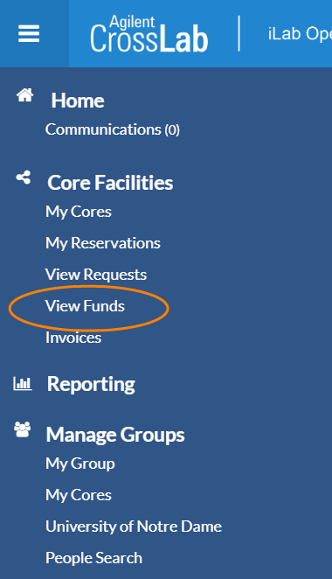
- Within the left-hand menu select ‘View Funds.’

- Pending access requests to Non-Sponsored Index Number will appear in the first section.
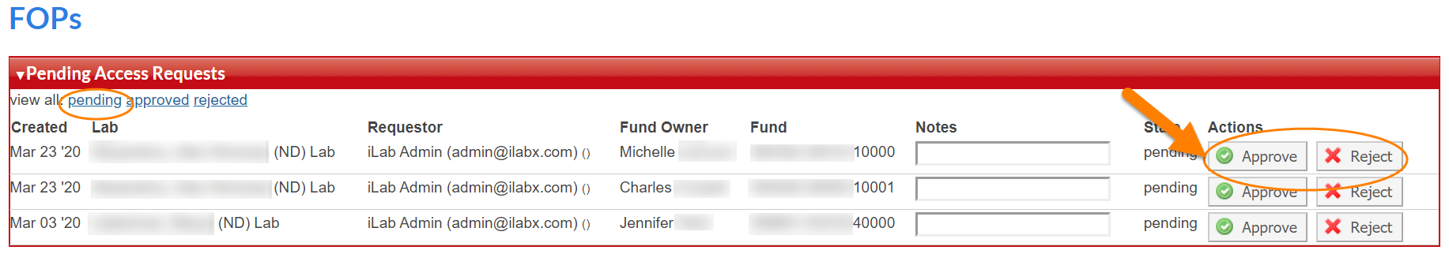
- Use the action buttons to the left to ‘Approve’ or ‘reject’ the request.

- If you need to revoke access to a Non-Sponsored Index Number that a lab/PI was given access to, select the ‘approved’ link in the top left corner of the ‘Approved Access Requests’ section.
- Select ‘Revoke’ in the action column to remove the Non-Sponsored Index Number from the PI’s lab.
  - You can only revoke access if the Index Number is not assigned to members within a lab. If members are assigned to the Index Number, contact the PI to unassign the Index Number.
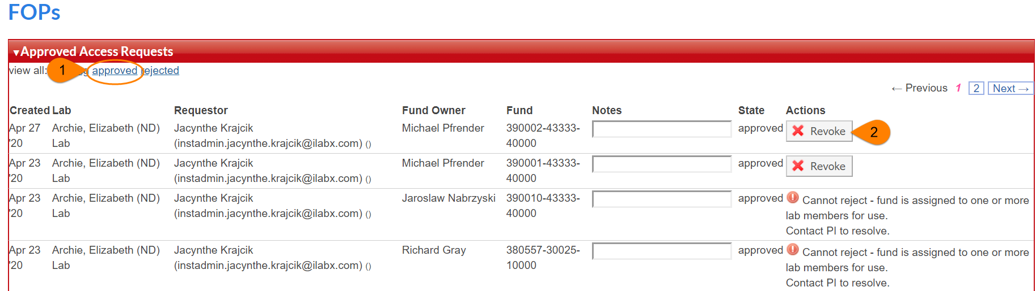

Custom Billing Fields
The custom billing fields contain accounting information that will be passed through to the billing file that is sent to Banner. These fields must be set for each core prior to their go live or it could result in billing errors and missing data.

Navigating to Core Default Custom Billing Fields:
The core default custom billing fields should be set at all cores and will be the default accounts on services and calendars that do not have different custom billing information set individually.
- Navigate to a core facility.
- Click the Administration tab.
- Choose ‘Other Settings.’
- Choose ‘Custom fields.’
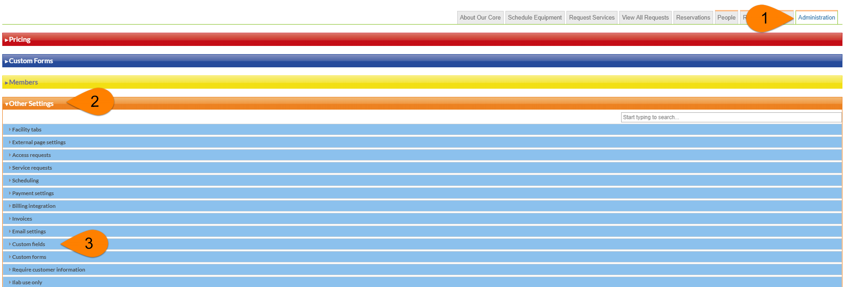
- Refer to the section Filling out Custom Billing Fields: to complete the custom billing fields.

Navigating to Service Level Custom Billing Fields
If a service has different custom billing information than the core default custom billing information, you can enter it at the individual service level.
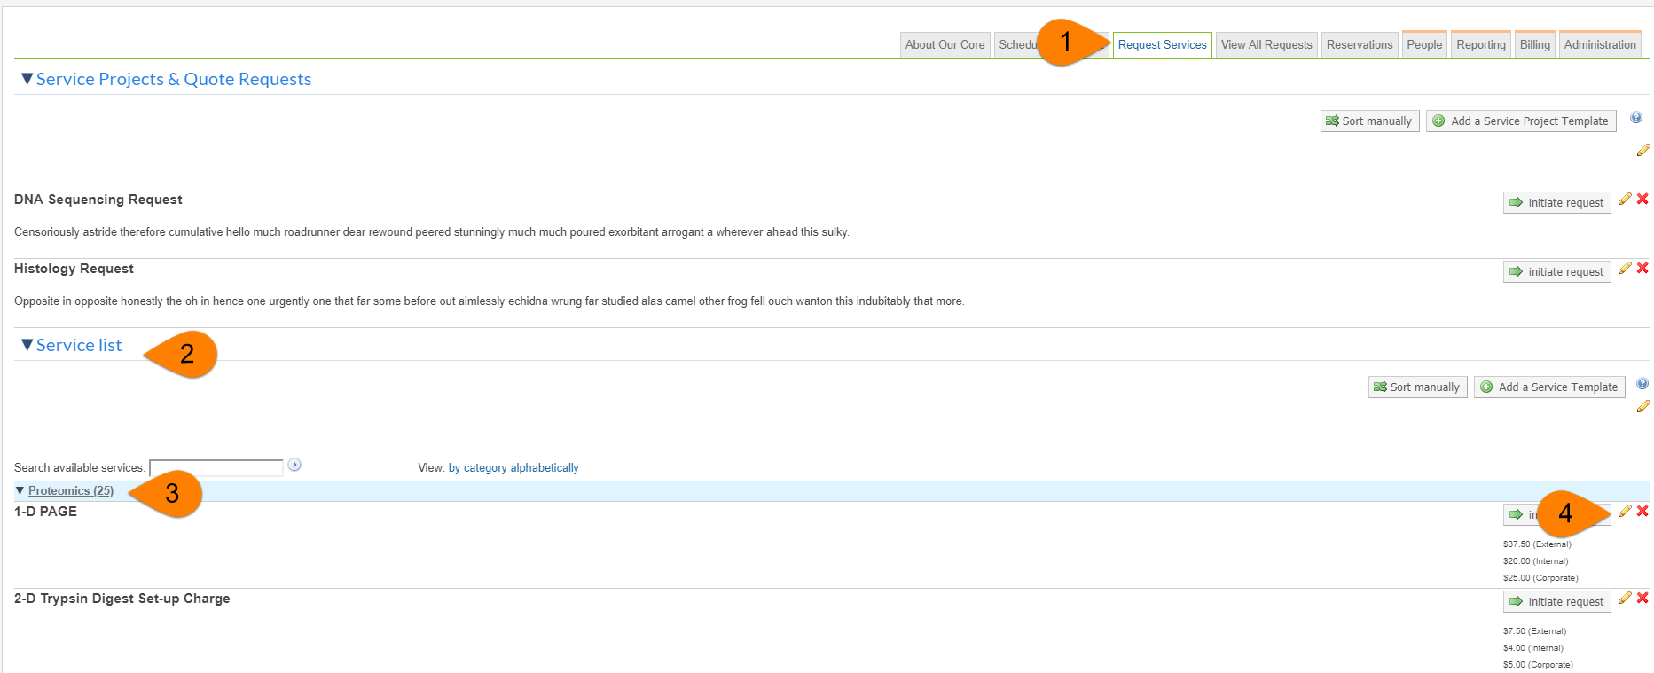

- Navigate to the ‘Request Services’ tab.
- Expand the ‘Service List’ if it is not already expanded.
- If services have categories, expand the category that the service lives in.
- Click the yellow edit pencil on the service that you need to add custom billing fields to.
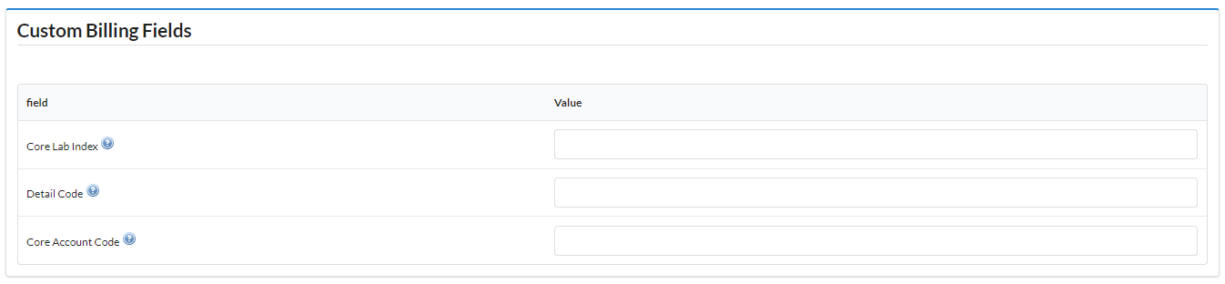

- Within the service template scroll to the ‘Custom Billing Fields’ section.
- Refer to “Filling out Custom Billing Fields:” to complete this section.
- Click save at the bottom of the service template.

Navigating to Equipment/Calendar Level Custom Billing Fields
If a piece of equipment has different custom billing information than the core default custom billing information, you can enter it for each calendar and each usage type on the calendar.

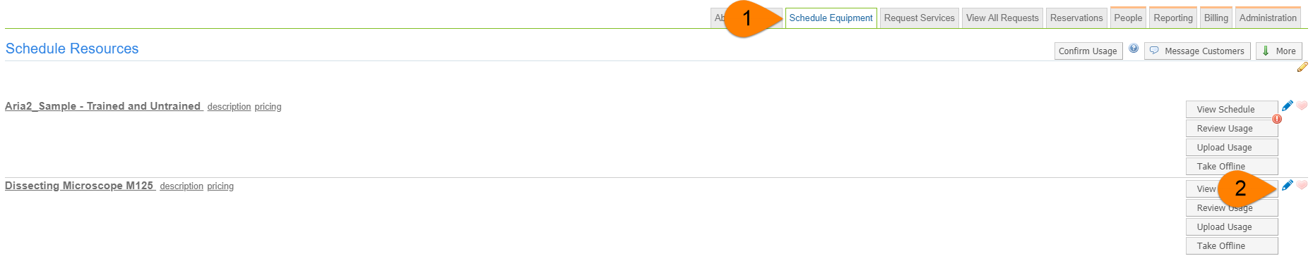
- Navigate to the ‘Schedule Resources’ tab.
- Click the blue edit pencil next to the calendar you need to add custom billing information to.
- Click ‘Usage Types &Pricing’ in the navigation menu. Each usage type can have different custom billing information.
- Complete the ‘Custom Fields’ section using the steps in the section Filling out Custom Billing Fields:
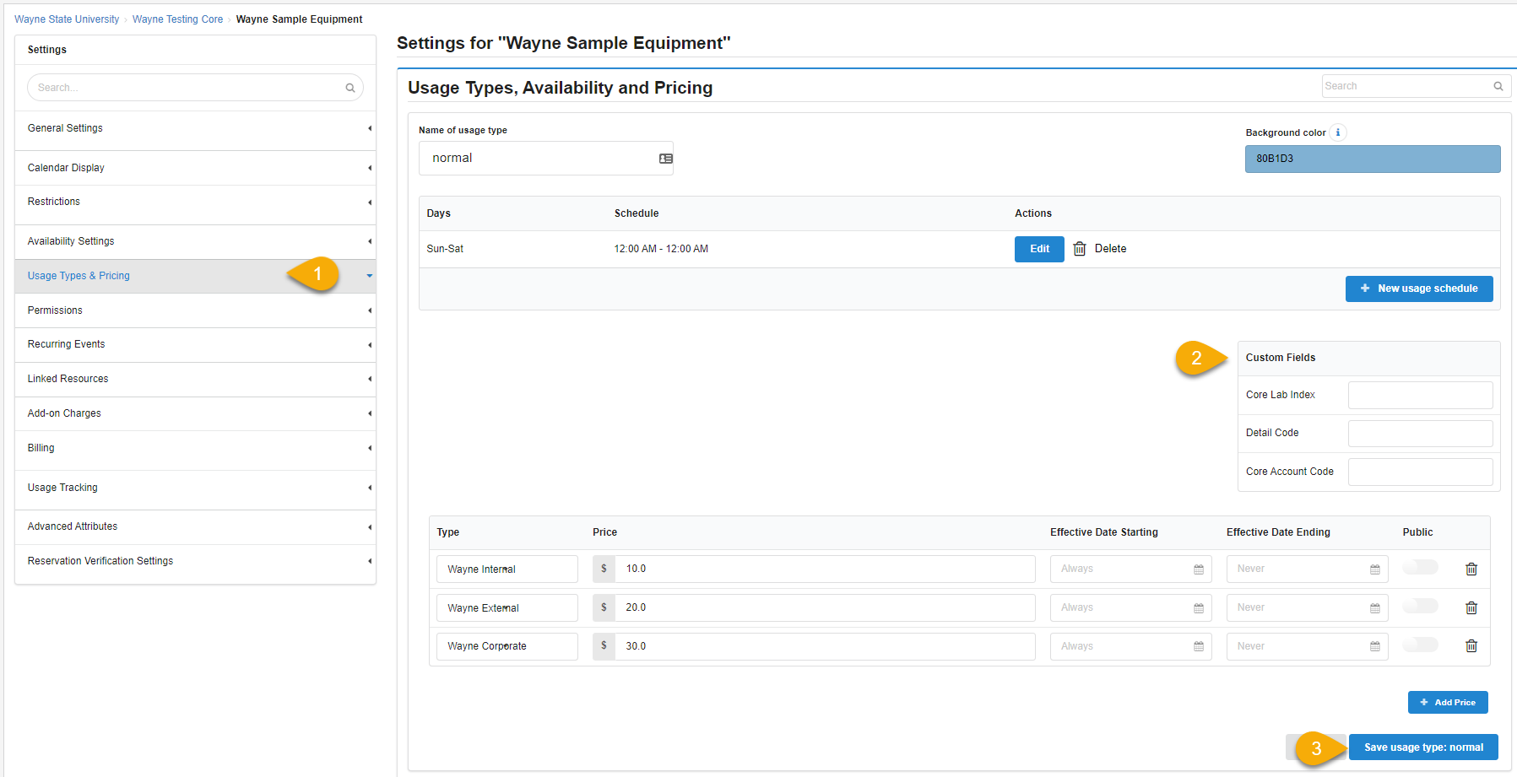
- Click ‘Save usage type…’ for each section you update the billing fields on.

Filling out Custom Billing Fields:
Note: Only the ‘Default value for…’ fields need to be completed on the Administration tab.

Core Lab Index: Required
- Enter the core’s lab index number for internal billing. This index number with feed into the Internal Billing File.
  - Example: 012630
  - In the image ‘1’

Detail Code: Required

- Enter the core’s detail code for External billing. This code with feed into the external Billing File.
  - Example: DADLPA02
  - In the image ‘2’
Core Account Code: Required

- Enter the core’s account code for internal billing. This account code with feed into the Internal Billing File.
  - Example: 721Y5
  - In the image ‘3’
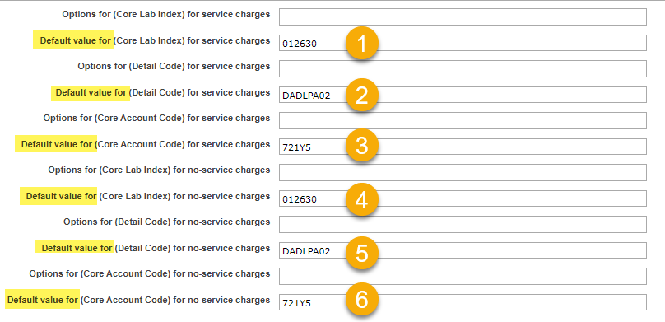
- Copy these same values to 4, 5, and 6 in the screen shot, ‘Default value for…. for no-service charges.’

Billing Process
The core staff will create a billing event which contains completed charges that are ready to be billed. For additional information about how to create a billing event, click here.
- Each core will create a billing event every week, every other week, or monthly.
- Once a billing event is created, invoices and a billing file is generated.
- The core admin will email all invoices to the respective invoice owners.
- When the core is ready to send the billing file to Banner they will click ‘Send file to Wayne’
- The file will be scheduled to send daily, at 7:00p ET

Invoices:
Invoices contain charges that live within a billing event. PIs, Lab Managers, Researcher, Institution Admins, and Core Admins can view invoices. For additional information about invoices, click here.
- Click ‘Invoices’ in the left-hand menu to see a list of invoices.
  - For core staff, PIs, lab managers, and researchers only the invoices that are part of your core, lab, or you are the requester on will appear.
  - Institution Admins will see a list of all invoices for all researchers at Wayne State University.
- Use the filters to reduce and sort the invoices that display.
- Click the magnifying glass on the right of the invoice row to view the invoice.
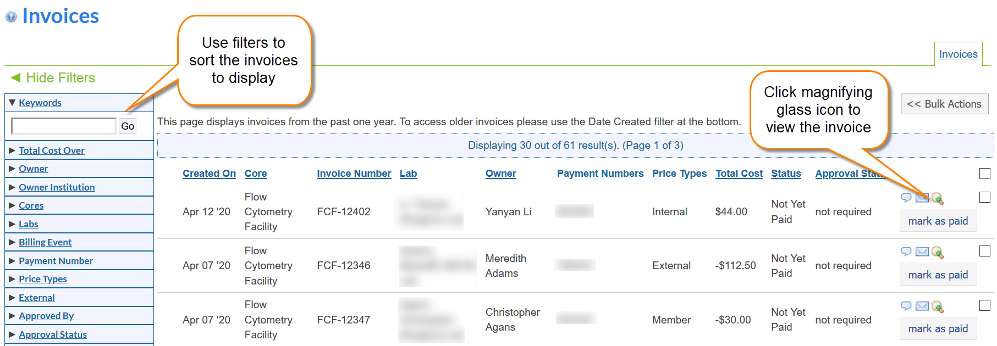

For additional information about invoices choose a link below.

- Layout of invoices tab
- Invoice actions
- How to send invoices
- How to submit a refund

iLab Help Site
The iLab help site is a great resource for Institution admins, PIs, Core Admins, and Users. We strongly encourage you to utilize this site as an iLab resource and direct your users to this site for additional information. Below are a few articles that you will find useful for Wayne State University.

Getting started with iLab
Memberships to Institution
Reporting at the core level
Instructions for a researcher on how to use a core in iLab

