Find Funding
Promote Your Work

www.cos.com


Wayne State University subscribes to COS services so that, whether your work is in the sciences or the arts, COS funding and expertise services can help support and advance your research. Update your profile now to take advantage of these services, and to help our institution promote its work.

COS Services
Make the most of your expertise using:
- COS Expertise—Profile tool for collecting and managing your professional information, to promote your work, and to find collaborators
- MyProfile—your professional homepage: http://myprofile.cos.com/YourUsername.
- CV and BioSketch Generation—manage and output your information from one source.
Find all the funding you need using:
- COS Funding Opportunities—world’s largest listing of available grants, fellowships, prizes and more.
- COS Funding Alert—delivers relevant new opportunities to your desktop.

Search COS Funding Opportunities
Go to http://fundingopps.cos.com or choose the Search COS Funding Opportunities tab on your COS Workbench. Choose a search option , enter your search criteria (e.g., citizenship, desired activity location, etc.) in the appropriate fields, and click Search.
On the results page you can re-sort the results, view key information, and refine your search
You can save searches to your COS Workbench and share them with other. You can also track individual record on your COS Workbench, tag and share them.

Manage Your COS Funding Alerts
Log in to your COS Workbench from http://www.cos.com. In the “Your Saved Funding Searches” section, you’ll see that an introductory search has been set. Follow the “Edit” link to change it.
To add a new alert search, simply create and run a new search in COS Funding Opportunities and click “Save Search” at the top of the results list. As prompted, name your search and select to receive email alerts for the search. Saved alert searches will run against the hundreds of records that are new or updated each week. You will receive results weekly via e-mail.

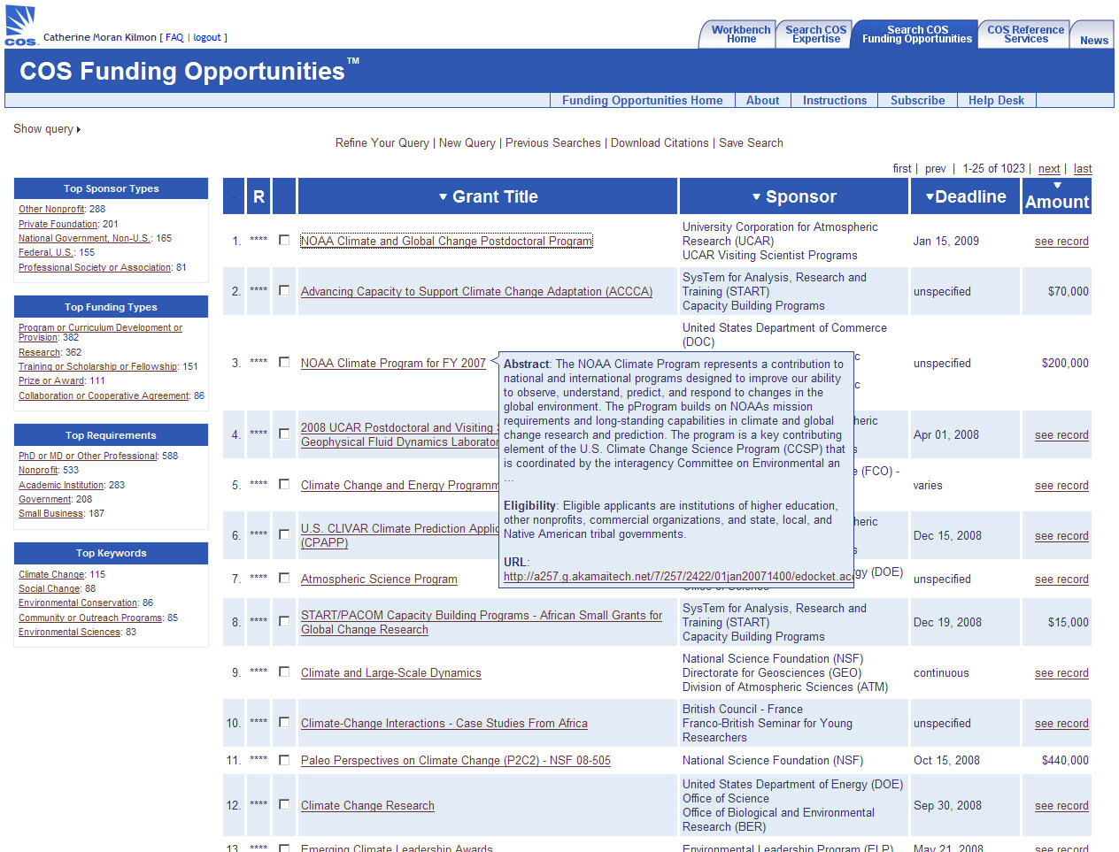
Search COS Expertise
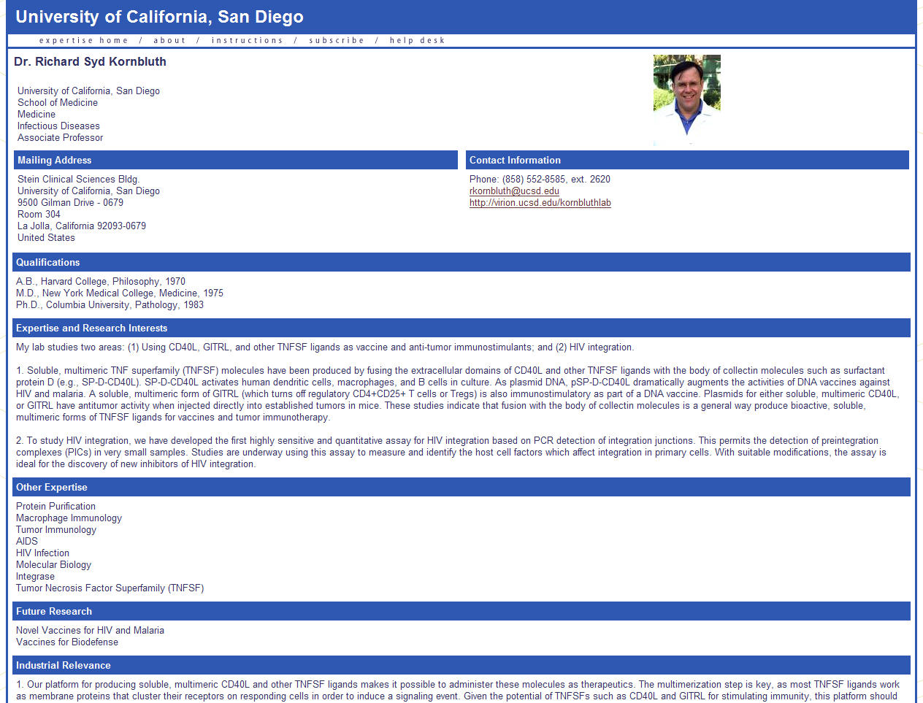
Go to http://expertise.cos.com. Choose a search option, e.g., Main Search. Enter your search criteria, e.g., institution or person name, descriptive terms. Click ‘Do the Search.’ Click names in the results list to see a full profile.
Update Your COS Profile Now!
It’s as easy as 1-2-3 to get the benefits of COS services.
- Login at www.cos.com
- username:
- password:
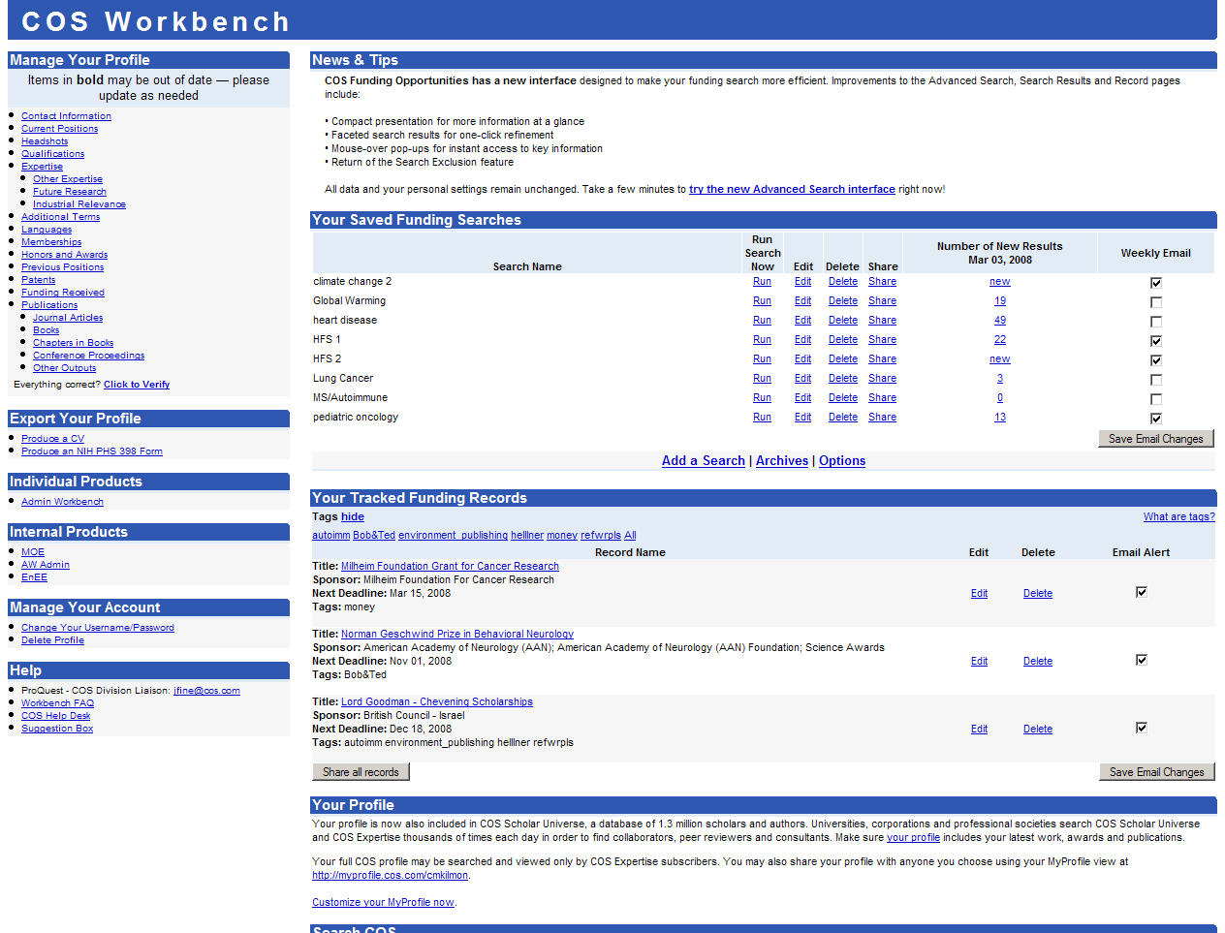
- Click any section under ‘Manage Your Profile’ on the left
- Edit a section, copying and pasting from other sources if desired, and save changes
Output Your CV

Librarians for the 21st Century
Log in to your COS Workbench from http://www.cos.com. In the ‘Export Your Profile’ section on the left, click “Produce a CV.” Choose which elements of your profile to include, in which order. Submit for processing. Save it to disk or open it in your word processing package.

Questions?

Contact Sarah James

sjames@wayne.edu

577-8997

PHONE


COS.com
Resources for Research, Worldwide
COS is a business unit of ProQuest

